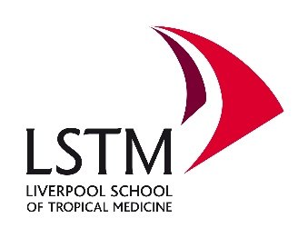
Standing Order Form

Thank you for making a regular donation to Liverpool School of Tropical Medicine (LSTM). Please complete this form and return it to: Fundraising Department, LSTM, Pembroke Place, Liverpool, L3 5QA, UK.

Title:……… First name:………………………….…… Surname:…………………………………

Address:…………………………………………………………………………………………………

Postcode:………………….

I would like to make a regular donation to Liverpool School of Tropical Medicine of:

£……………………….……..monthly or £ …………………….…. annually

Please debit the above amount from my account on or around the:

Date:………………(for Monthly) Date:………….…Month:……………….(for annual)

Instruction to you bank or building society to pay standing orders
To: The Manager
Name of bank/Building Society:……………………………………………………………………………….
Address of branch:……………………………………………………………………………………………….
Postcode:……………………………….

Branch sort code:……..-……..-………Bank/Building Society: account number:…………………………….

Signature (s):……………………………………………….. Date:……………………………………

And thereafter the same sum instalments to RBS, PO BOX 39952, 2 ½ Devonshire Square, London, EC2M 4XJ. Bank account name: Liverpool School of Tropical Medicine. Account number: 23176281
Sort code: 15-10-00
If you are a taxpayer, you can make your donation worth more with Gift Aid. For every pound you give to us, we get an extra 28p from the Inland Revenue. All you need to do is check the statement below and tick the box.

To qualify for Gift Aid, what you pay in income tax or capital gains tax must at least equal the amount we will claim in the tax year. I declare all gifts of money that I’ve made to Liverpool School of Tropical Medicine in the past six years and all future gifts of money that I make from the date of this declaration are Gift Aid donations. □

Please notify us if you want to cancel this declaration, change your name or home address or no longer pay sufficient tax on your income and/or capital gains.

Data Protection Statement
Liverpool School of Tropical Medicine recognises the importance of personal privacy and as such is registered under the Data Protection Act 1998.

Any personal information you provide will be held in accordance with the provisions of the Data Protection Act 1998 and used only for the reason specified at the point of collection. We will not sell, licence or trade your personal details to any third party. Personal information provided by you, and any other information relating to you, held by LSTM, may be used for LSTM’s own management purposes, or occasionally shared with other organisations in line with legal compliance, for example, in the prevention of crime.

In future LSTM may wish to send you fundraising updates or news, please tick here if you would prefer not to be contacted by LSTM. □

Liverpool School of Tropical Medicine is a charity registered in England and Wales, number: 222655.

