Part A: Programme Summary Information

1 | Title of Programme | Diploma in Tropical Medicine & Hygiene
2 | Programme Code | DTM&H
3 | Entry Award (s):
3a | Entry Award 1 | N/A
3b | Entry Award 2 | N/A
3c | Entry Award 3 | N/A
4 | Exit Award (s):
4a | Exit Award 1 | N/A
4b | Exit Award 2 | N/A
4c | Exit Award 3 | N/A

5a | Start Date | September 2023 |  | 5b | End Date | September 2024
6 | Frequency of Intake | Twice yearly (Sept and Feb)
7 | Mode of Study | FT
8a | Applicable Framework | UoL Framework for FT or PT Postgraduate Programmes
8b | Exemption Required
8c | Exemption Approved
8d | Details of Exemption
9 | Programme Director | Christopher Parry
10 | Board of Studies
11 | Board of Examiners
12 | External Examiner(s) | Dr Paul Collini (University of Sheffield) (Clinical)  Professor Chris Smith (LSHTM) (Public Health)  Dr Bonnie Webster (Natural History Museum (TDB)
13 | Professional or  Other Body | None
14 | Reference Points | None
15a | Home/EU Fee |  |  | 15b | Overseas Fee
16 | Additional Costs to the Student

Part B: Programme Aims and Outcomes
17 | Overview of the Programme
The DTM&H is a well-established programme of international repute designed for physicians who want to improve the health and well-being of people living in low and middle-income countries (LMICs)
18 | Aims of the Programme
No. | Specific Aim |  | Entry Award
1 | To develop students' knowledge and comprehension of the clinical presentation, diagnosis and management of major communicable, non-communicable, and neglected tropical diseases in LMICs, and critically review principles of their epidemiology and control.
2 | To enable students to critically analyse application of global health policies and public health principles in LMICs and develop skills needed to manage health programmes in low resource settings.
3 | To develop students' knowledge of the biological details essential for identification and diagnosis of major pathogens and vectors of disease in LMICs, their epidemiology and a critical understanding of their control, elimination and eradication.
19 Skills and Other Attributes
No. |  | Skill/Attribute |  | Module(s) | Mode of Assessing
1 |  | To communicate ideas, knowledge, and strategies confidently and effectively |  | N/A | All assessments
2 |  | To demonstrate awareness of ethical issues arising in medical practice in LMICs. |  | N/A | Papers 1,2 and 3
3 |  | To work effectively both independently and in collaboration with others from a range of disciplines. |  | N/A | Papers 1 and 2
4 |  | To take responsibility for self-managed learning |  | N/A | All assessments
5 |  | To apply skills in effective time management |  | N/A | All assessments
20 | Subject Based Learning Outcomes
A | Knowledge and Understanding. Upon successful completion of the programme, a student should have developed and be able to demonstrate:
No. | Learning Outcome |  | Module(s) |  | Mode of Assessing | Entry Award
A1 | Evaluate the clinical presentation, diagnosis and management of major communicable, non-communicable and neglected diseases in LMICs, and explain principles of their epidemiology and control. |  | N/A |  | Papers 1, 2, 3
A2 | Analyse specific health and health system challenges affecting vulnerable groups living in LMICs and choose strategies and apply programme management principles to overcome them. |  | N/A |  | Papers 1, 2, 3
A3 | Explain and illustrate the importance of social, cultural and economic factors on planning, management, implementation and uptake of preventative and curative health services and disease control programmes in LMICs. |  | N/A |  | Papers 1, 2
A4 | Appraise major diagnostic strategies for controlling diseases of LMIC and identify relevant stages of development of important pathogens and vectors responsible for causing and transmitting human disease in LMICs. |  | N/A |  | Papers 1, 2, 3
A5 | Summarise key biological characters of major insect vectors of disease and explain their relevance in the epidemiology and control of communicable diseases in LMICs. |  | N/A |  | Papers 1, 3
B | Cognitive Skills. Upon successful completion of the programme, a student should be able to:
No. | Learning Outcome |  | Module(s) |  | Mode of Assessing | Entry Award
B1 | Analyse, synthesise and evaluate information from a variety of sources in a critical manner; e.g., evaluate clinical practice according to national/international management guidelines. |  | N/A |  | Paper 1, 2, 3
B2 | Apply subject knowledge and understanding in a variety of contexts to analyse and reach evidence-based conclusions on complex situations, problems and opportunities |  | N/A |  | Paper 1, 2, 3
B3 | Demonstrate creativity, innovation and originality in the application of knowledge |  | N/A |  | Papers 1, 2, 3

C |  | Practical/Professional Skills. Upon successful completion of the programme, a student should be able to:
No. |  | Learning Outcome | Module(s) | Mode of Assessing | Entry Award
C1 |  | Identify and describe pathogens important in the diagnosis of diseases of LMICs and distinguish these from non-pathogenic organisms. | N/A | Paper 1, 3
C2 |  | Identify important insect vectors of disease in LMICs | N/A | Papers 1, 3
C3 |  | Lead and participate in a health professional team and personally manage clinical problems commonly encountered in LMICs. | N/A | Papers 1, 2
C4 |  | Devise strategies for assessing and improving community health in LMICs. | N/A | Paper 1, 2
C5 |  | Design programmes, prepare action plans, and evaluate them to produce effective public health interventions for vulnerable communities and populations, including those affected by conflict and disaster. | N/A | Paper 1,2
21 | Career Opportunities
The programme provides excellent career development for doctors intending to work in low- and middle-income countries in clinical services, public health, research, and emergency relief programmes in association with government, NGOs and international organisations.
The programme is also directly relevant to practitioners in high income countries, particularly those involved in infectious diseases, HIV, maternal, newborn and child health, communicable disease control, travel health, emerging disease, emergency medicine, general practice and research.

Part C: Entrance Requirements

22 | Academic Requirements | A recognised medical degree. Advanced Nurse Practitioners with relevant infection experience will be eligible at the discretion of the Programme Director.
23 | English Language Requirements | The programme is taught in English. Applicants whose first language is not English must normally provide evidence of an IELTS (International English Language Testing System) score of at least 6.5 with a minimum of 5.5 in all learning components, or a TOEFL (Test of English as a Foreign Language) score of at least 88 for the Internet-based Test (iBT), with minimum scores of 21 for Listening and Writing, 22 for Reading and 23 for Speaking. Tests should be in their validity period of 2 years. Other English Language Tests and country specific English Language qualifications are also accepted - a full list with details of levels required can be found on the LSTM website (http://www.lstmed.ac.uk/study/how-to-apply/english-language-requirements). Applicants who have recently completed a degree level qualification taught in a majority English-speaking country (as defined by UK Visas and Immigration (UKVI)) may also be accepted at the discretion of the Director of Studies.
24 | Recognition of Prior Learning | All programmes of study will permit entry with credit attributed to previous certificated study up to a total of one third of the credits required to be awarded a Master’s Degree, Postgraduate Diploma or Postgraduate Certificate.
25 | Work Experience | At least 2 years' experience of professional work after qualification.
26 | Other Requirements | None.

Part D: Programme Structure
27a | Overview
This is an integrated, non-modular programme of training based around the three core themes of Clinical Tropical Medicine (including, maternal, newborn and child health), Tropical Disease Biology (including parasitology, microbiology, and vector biology), and Public Health and Disease Control in LMICS. It is achieved through lectures, practical lab sessions, seminars, clinical problem-based tutorials, self-directed study and case presentations. The international multi-cultural nature of the programme presents students with a variety of ethical viewpoints relevant to the provision of health case in LMICs.
Lectures, tutorials and seminars cover a wide range of communicable, non-communicable and neglected tropical diseases. Where relevant, clinical lectures are integrated with complementary parasitology, microbiology and vector biology lectures and associated practicals. Many of these also include public health aspects which, in turn, are supported by dedicated sessions on public and community health and disease control programmes.
Whole class seminars, that usually involve small group work, are conducted on malaria, HIV, TB, maternal, newborn and child health and vector biology and public health. There is also a series of small group clinical problem solving sessions. Occasionally, clinical cases and emerging or emergency health problems are discussed with colleagues overseas in LMIC setting during live Webinars. Frequent revision sessions are held, particularly in practical and laboratory skills. In addition, students have access to the teaching laboratory for personal study and revision.
Staff from a range of disciplines through the School are involved, including adult physicians, paediatricians, public health practitioners, epidemiologists and infectious disease scientists with wide experience in LMICs. Visiting lecturers from departments of the University of Liverpool, local NHS Trusts and other institutions complement the learning experience.
In addition to allocated personal study time, students are also provided with on-line information-rich preparatory modules and training videos to allow better use of contact teaching time, and to develop skills in applied problem solving.
27b | Timetable
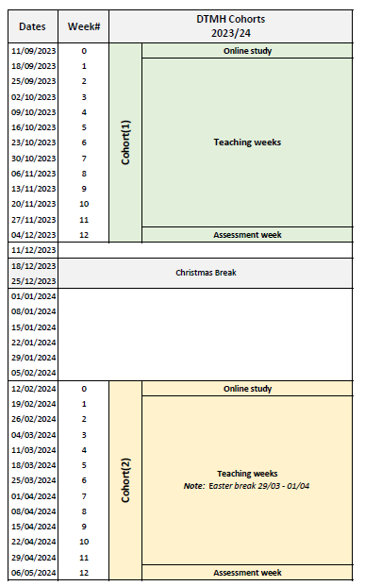
27c | Options
n/a

Part E: Learning, Teaching and Assessment Strategies
28 | Learning, Teaching & Assessment Strategy
This wide-ranging programme draws on the personal experience of the teachers and many of the students.
The learning and teaching strategy recognises the effectiveness of small working groups for building capacity in problem solving, analytical thinking, synthesising information from multiple sources and evaluating from different perspectives. The cosmopolitan nature of the student cohort greatly adds value to this activity.
Practical classes/sessions extend the learning experience and enable the students to develop a number of hands-on skills. They are supported with a range of demonstration materials, and overseen by experienced academic and technical staff.
An excellent specialised library and access to computers and the internet across the teaching environment provide additional learning resources.
Face-to-face learning is complemented by group work, laboratory practicals, on-line learning and revision resources. Some presentations are delivered using an on-line platform which also allows for interaction with overseas colleagues.
29 | Assessment Schedule
The assessment strategy is designed to enable the student to demonstrate a range of clinical, diagnostic, biological and public health skills, including analysing, synthesising and evaluating information, and identification of important pathogens and vectors. Both formative and summative assessment approaches are used. General assessment procedures, assessment criteria and regulations are communicated to students in the DTM&H Student Handbook.
The assessments will be on-site during week 12. Note: the exam format may have to be adapted to allow remote examination when OCVID-19 restrictions prevent on -site examinations.
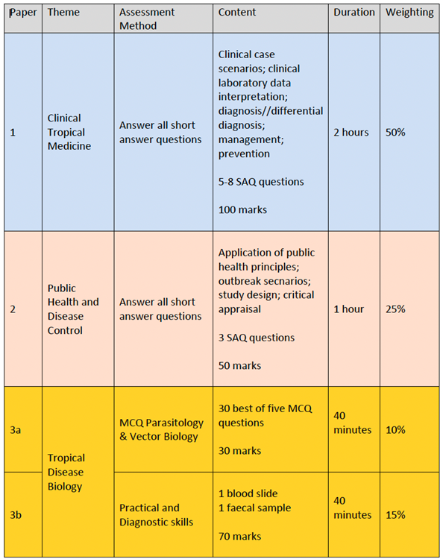
The marks for each theme will be allocated as follows
Paper 1 (50%): Clinical Tropical Medicine
Paper 2 (25%): Public Health and Disease Control
Papers 3a & 3b (25%): Tropical Disease Biology

30 | Pass Mark
Candidates must pass each of the three papers (Paper 1, 2, and 3)
Students who pass each assessment and achieve a combined mark of >=50% will be awarded a Pass
Students who pass each assessment and achieve a combined mark of >=70% will be awarded a Distinction
The student who scores the highest mark in each paper will be awarded the prize in Clinical Tropical Medicine (Paper 1), Public Health and Disease Control (Paper 2), Tropical Disease Biology (Paper 1), provided they are in the top five of students for the overall marks. Each student can only be awarded one prize. If a student scores the highest mark in two papers, the student with the next highest mark will be awarded the prize in one of those papers.
31 | Compensation and Resits
Students are entitled to re-sit failed paper(s) on one occasion only. All re-sits must take place on the same occasion. Provided a mark of 50% or above is achieved on a re-sit paper, the mark for that (those) paper(s) is capped at 50%. The overall Diploma mark is not capped.
32 | Marking Descriptors
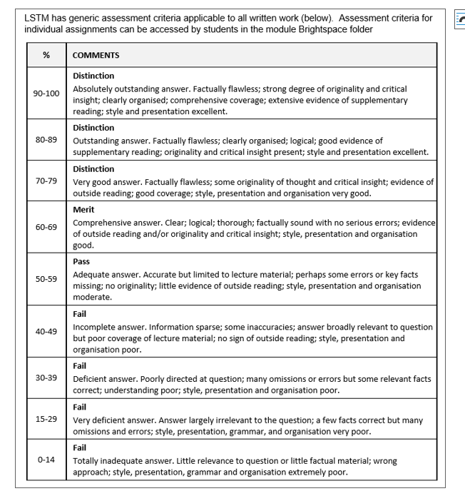

33 | Final Award and Alternative Qualifications
Diploma in Tropical Medicine and Hygiene (DTM&H)

Part F: Quality Assurance

34 | Examination Process
The DTMH Board of Examiners consists of the Chair (either the Director of Education PGT/PGR or Reader in Education) the Programme Director, the Quality Assurance Manager or Senior Quality Assurance Administrator, the Programme Administrator, the External Examiner and all members of academic staff who have made a major contribution to the teaching and assessment of the programme.
The Terms of Reference are as follows:
- To monitor methods of assessment against set learning outcomes and programme requirements
- To ensure standards of assessment are maintained
- To assess students’ performance in accordance with regulations
- To reach overall decisions concerning awards
- To make recommendations to the Board of Studies on the conduct and standards of all assessment procedures
The External Examiner is responsible for ensuring that awards made by the LSTM are of a comparable standard with those of similar subjects and awards of other Higher Education Institutions in the United Kingdom, as stated in the Code of Practice on External Examining which is available at: http://www.lstmed.ac.uk/study/quality-manual
Further information on the assessment policies and procedures can be found in the LSTM Diploma in Pharmaceutical Systems Student Handbook.
Information on the purpose, method and schedule of assessment and the timescales for the submission of assessments can be found in the Programme Handbook available on the LSTM student VLE (Virtual Learning Environment) Brightspace.
Marking processes
Internal and external verification of all papers.
Structured marking schemes for written papers.
Moderation: Moderation sample to be 25% or 10 scripts; whichever is the larger and should cover the range of marks.

35 | Student Representation and Feedback
Students have daily access to the Director of Studies and other teaching staff.
Academic or personal difficulties can be resolved quickly by a friendly, concerned member of staff, or through being referred for help elsewhere. The School has a Student Experience Officer who is available to help with personal problems.
Participants contribute to the evaluation of the programme and its various components throughout the programme, for example, by completion of online evaluation forms for individual teaching sessions and a final programme questionnaire.
The evaluations are made available; to the Director of Studies and Theme Leads on a weekly basis and issues arising are reported at Board of Studies (BOS) meetings, together with any additional feedback from the student representatives.
Two selected student representatives participate in meetings of BOS (usually 2 meetings per term).
Part G: Diversity and Equality of Opportunity and Widening Participation
36 | Diversity and Equality Statement
The programme’s design, structure and content are consistent and compliant with the Diversity and Equality of Opportunity Policy. LSTM provides a multicultural, multidisciplinary learning environment in which all students benefit from the opportunity to share diverse experiences and outlooks, supported by staff who are themselves from a variety of national and cultural backgrounds and spend significant periods of time working overseas. LSTM recognises that some students need extra help and guidance in adjusting to a new country, culture or learning environment. Accordingly, we provide a comprehensive range of relevant non-academic student support services. The Director of Studies aims to provide students with advice and support in matters related to academic work and to enable the development of independent study habits suitable for higher education. Reasonable adjustments are made to assessment for disabled students in line with the Code of Practice on Student Support and Welfare.

Part H: Status of Professional, Statutory or Regulatory Body Accreditation
37 | Accreditation Status
The award of Diploma (DTM&H) is made by the Liverpool School of Tropical Medicine, based on the results of examinations held at the end of the programme. The DTM&H is recognised by the RCPs UK and numerous International bodies.

Annex: Modifications
Annex of Modifications made to the Programme - Related List of Modification
Description of Modification (Please include details of any student consultation undertaken or confirm that students’ consent was obtained where this was required) | Major/Minor Modifications | Date Approved by QMC | Date Approved by Mgt Cttee | Cohort Affected

