Part A: Programme Summary Information

1 | Title of Programme | Professional Diploma Pharmaceutical Systems
2 | Programme Code | DPS
3 | Entry Award (s):
3a | Entry Award 1 | Professional Diploma Pharmaceutical Systems
3b | Entry Award 2 | N/A
3c | Entry Award 3 | N/A
4 | Exit Award (s):
4a | Exit Award 1 | N/A
4b | Exit Award 2 | N/A
4c | Exit Award 3 | N/A

5a | Start Date | September 2023 |  | 5b | End Date | August 2024
6 | Frequency of Intake | Annually
7 | Mode of Study | PT
8a | Applicable Framework | LSTM Reg 02 Professional Diploma Programmes
8b | Exemption Required
8c | Exemption Approved
8d | Details of Exemption
9 | Director of Studies | Rocio Villacorta Linaza
10 | Board of Studies | Professional Diploma Pharmaceutical Systems
11 | Board of Examiners | Professional Diploma Pharmaceutical Systems
12 | External Examiner(s) | Dr Khalid Ahmad Sheikh
13 | Professional or  Other Body | None
14 | Reference Points | QAA subject benchmarks for health studies: https://www.qaa.ac.uk/docs/qaa/subject-benchmark-statements/subject-benchmark-statement-health-studies.pdf  The frameworks for HE qualifications of UK degree-awarding bodies:  https://www.qaa.ac.uk/docs/qaa/quality-code/qualifications-frameworks.pdf?sfvrsn=170af781_14
15a | Home/EU Fee | £6500 |  | 15b | Overseas Fee |  | £6500
16 | Additional Costs to the Student | None

Part B: Programme Aims and Outcomes
17 | Overview of the Programme
Pharmaceutical systems are essential to health systems in all countries, regardless of income status. The main objectives of a pharmaceutical system are to provide access to medicines, encourage their rational use, and assure their quality, safety, and efficacy. The recent COVID-19 pandemic highlighted both the complexities and vulnerabilities of these objectives and underscored the importance of making pharmaceutical systems more resilient. This Professional Diploma aims to equip you with a comprehensive overview of pharmaceutical systems and the development of relevant analytical, operational, and applied professional skills.
The Professional Diploma Pharmaceutical Systems (PDipPharma) is awarded by the Liverpool School of Tropical Medicine (LSTM) as a Professional Diploma aimed at equipping both new and experienced professionals with the knowledge, skills, and competencies in pharmaceutical systems to analyse, synthesise, evaluate, and apply programme content in day-to-day work. Through interactive online study and access to LSTM’s library resources, you will learn together with peers from across the globe that will build your professional network and your potential for career development.
The programme is delivered through the following three online modules:
Module 1 - Pharmaceutical Systems and Access.
Module 2 - The Pharmaceutical Supply Cycle.
Module 3 - Pharmaceutical Systems Strengthening.
LSTM and QUAMED (https://Quamed.org) have set a collaboration up for the learning units related to quality of medicines in module 1 and 2.
The course is open to pharmacists, doctors, nurses, and health professionals with 1- 2 years proven experience in pharmaceutical systems.
18 | Aims of the Programme
No. | Specific Aim |  | Entry Award
1 | Critically analyse the barriers and enablers to access to medicines including quality of medicines, regulatory environment, and affordability within different health systems. |  | PDipPharma
2 | Evaluate key areas of each phase within the pharmaceutical supply cycle across different contexts. |  | PDipPharma
3 | Assess the strengths, weaknesses, and gaps in a pharmaceutical system. |  | PDipPharma
4 | Design a comprehensive pharmaceutical system strengthening plan (appropriate to a given health system/program). |  | PDipPharma
19 Skills and Other Attributes
No. |  |  | Skill/Attribute | Module(s) | Mode of Assessing
1 |  |  | To generate, evaluate and appraise various forms of research evidence. | All taught modules | Formative and summative assessments/group work/oral presentations.
2 |  |  | To communicate ideas to different audiences, both orally, in writing and using information technologies. | All taught modules | Formative and summative assessments.
3 |  |  | To make critical decisions in complex and unpredictable situations. | All taught modules | Formative and summative assessments/group work/oral presentations.
4 |  |  | To take responsibility for independent and self-directed learning and managing set goals, time and prioritise to meet deadlines. | All taught modules | Group work  Formative and summative assessments.
5 |  |  | To work effectively both independently and collaboratively. | All taught modules | Online discussions, individual and group formative, and summative assessments.
20 |  | Subject Based Learning Outcomes
A |  | Knowledge and Understanding. Upon successful completion of the programme, a student should have developed and be able to demonstrate:
No. |  | Learning Outcome |  | Module(s) | Mode of Assessing | Entry Award
A1 |  | Critical evaluation of different aspects of pharmaceutical systems and access to medicines as well as their impact on professional practice. |  | Module 1 | Formative assessment.  Summative assessment – 2000 words policy brief based on a case study drawn from the literature or your own professional experience. | PDipPharma
A2 |  | Analysis of the key components of each phase of the Pharmaceutical Supply Cycle and how the phases are linked to each other. |  | Module 2 | Formative assessment.  Summative assessment – Written training plan based on a gap identified from a case study drawn from the literature or your own professional experience. | PDipPharma
A3 |  | Application of a methodology to design and implement a viable plan for strengthening pharmaceutical systems in any given context. |  | Module 3 | Formative assessment.  Summative assessment – pharmaceutical systems strengthening plan. | PDipPharma
B |  | Cognitive Skills. Upon successful completion of the programme, a student should be able to:
No. |  | Learning Outcome |  | Module(s) | Mode of Assessing | Entry Award
B1 |  | Critically appraise evidence of pharmaceutical systems as presented in relevant literature. |  | All taught modules | Individual presentation.  Written assignments.  Written report. | PDipPharma
B2 |  | Analyse and synthesise key areas of pharmaceutical systems from a variety of sources and provide solutions. |  | All taught modules | Individual presentation.  Written assignments.  Written report. | PDipPharma
B3 |  | Critically appraise solutions that will contribute to the improvement of pharmaceutical systems. |  | All taught modules | Individual presentation.  Written assignments.  Written report. | PDipPharma
C |  | Practical/Professional Skills. Upon successful completion of the programme, a student should be able to:
No. |  | Learning Outcome |  | Module(s) | Mode of Assessing |  | Entry Award
C1 |  | Identify, plan, and implement strategies relevant to pharmaceutical systems in various contexts. |  | All taught modules | Formative and summative assessments and during group activities during modules |  | PDipPharma
C2 |  | Analyse and communicate relevant pharmaceutical data and information in written and oral presentations. |  | All taught modules | Formative and summative assessments and during group activities during modules. |  | PDipPharma
C3 |  | Develop practical skills in how to design and present a strengthening plan in a particular context. |  | Module 3 | Formative and summative assessments and during group activities. |  | PDipPharma
21 | Career Opportunities
Pharmaceutical systems are a cross cutting theme for health programmes and health systems. Graduates can be involved with strengthening local and national pharmaceutical systems, developing strategies and policies around access to pharmaceutical. There are several potential employers of professional diploma graduates e.g., local authorities, agencies of the United Nations, World Health Organisation, local Ministries of Health, Health Departments, international donors, aid organisations or non-governmental organisations and charities. Graduates can become consultants, educators, researchers, or managers.

Part C: Entrance Requirements

22 | Academic Requirements | Qualified health care professional; including Pharmacist, Doctors, Nurses or health managers with proven experience of more than 1-2 years in the pharmacy field.
23 | English Language Requirements | The programme is taught in English. Students whose first language is not English must provide evidence of an IELTS (International English Language Testing System) score of at least 6.5 with a minimum of 5.5 in all learning components, or a TOEFL (Test of English as a Foreign Language) score of at least 88 for the Internet-based Test (iBT), with minimum scores of 21 for Listening and Writing, 22 for Reading and 23 for Speaking. Tests should be within their validity period of 2 years
24 | Recognition of Prior Learning | N/A
25 | Work Experience | Pharmacists, doctors, nurses, and health professionals with a minimum 1-2 years of demonstrated experience in pharmacy, either within national health programmes or in a related area such as pharmacy, hospitals, health centres, senior management roles, or industry.
26 | Other Requirements | Must have an interest in pharmaceutical systems and wish to extend and develop their knowledge further.

Part D: Programme Structure

27a | Overview
The Diploma in Pharmaceutical Systems is based around the successful completion of three core modules:
Module 1 – Pharmaceutical Systems and Access
Block 1: Introduction to pharmaceutical systems.
Block 2: Introduction to access to medicines.
Block 3: Quality of medicines (Block developed with the support of QUAMED).
Block 4: Affordability.
Block 5: Acceptability (regulatory system).
Module 2 – Pharmaceutical Supply Cycle
Block 1: Pharmaceutical supply systems.
Block 2: Selection.
Block 3: Procurement
Block 4: Storage Warehouse Management/Distribution (Block developed with the support of QUAMED).
Block 5: Rational use.
Module 3 – Pharmaceutical Systems Strengthening
Block 1: Introduction.
Block 2: Designing the plan.
Block 3: Setting the objectives.
Block 4: Building assessment tools.
Block 5: Monitoring, Evaluation and Learning (MEL).
Programme structure diagram
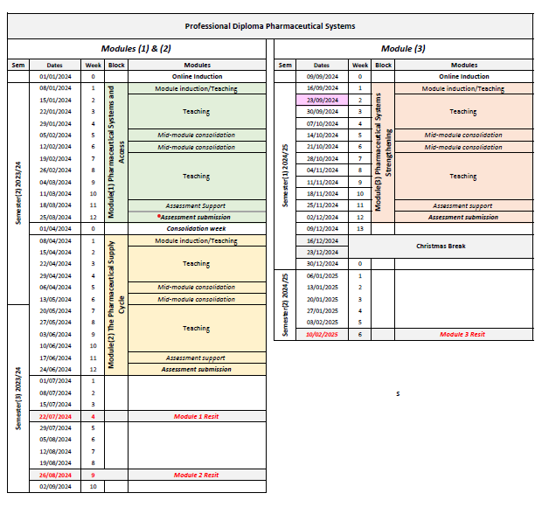

27b | Timetable
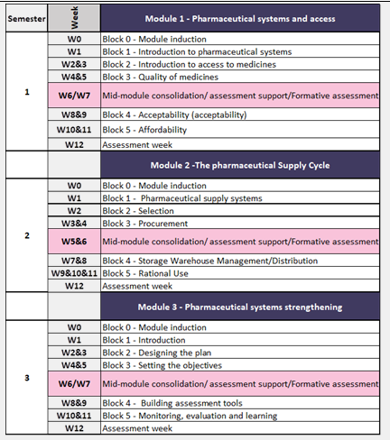
27c | Options
N/A

Part E: Learning, Teaching and Assessment Strategies
28 | Learning, Teaching & Assessment Strategy
Throughout the online learning process, a variety of learning and teaching approaches are adopted, including video lectures, online individual and group activities, podcasts, QA sessions, problem-based learning using case studies, discussion board, comprehensive reading lists, reflective practice and other activities which enable students to become self-directed learners who are able to integrate their learning to practice. A culture of reflective practice and self-evaluation is encouraged throughout.
The online platform provides a rich and encouraging environment in which students will acquire knowledge and skills throughout the duration of the Professional Diploma.

29 | Assessment Schedule
A combination of the following Learning and Teaching methods are applied to assist students in attaining learning outcomes:
Note: Summative assessments take place at the end of each module
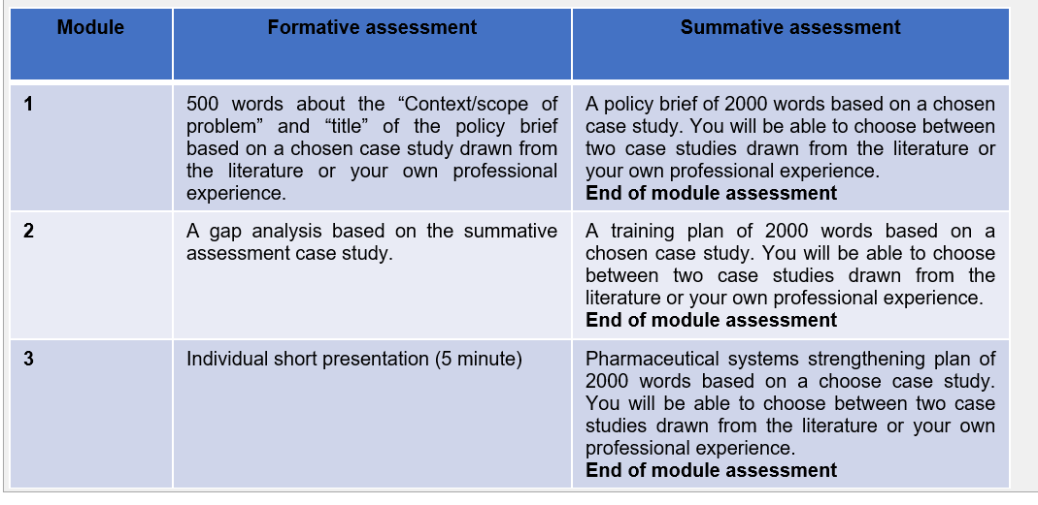
30 | Pass Mark
Candidates who successfully pass all three (50% pass mark) will be eligible for an LSTM awarded Professional Diploma in Pharmaceutical systems.
A grade of Merit will be awarded for candidates achieving an overall mark of 60-69%
A grade of Distinction will be awarded for candidates achieving an overall mark of 70% or above.
31 | Compensation and Resits
Candidates who fail summative assessments may re-sit those assessments on one further occasion at the discretion of the Board of Examiners.
32 | Marking Descriptors
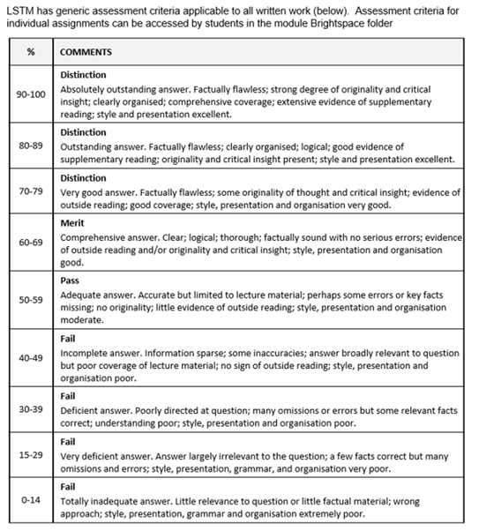
33 | Final Award and Alternative Qualifications
Candidates who successfully complete all three modules will be awarded the Professional Diploma Pharmaceutical Systems

Part F: Quality Assurance

34 | Examination Process
The PDipPharma Board of Examiners consists of the Chair (either the Director of Education PGT/PGR or Reader in Education) the Director of Studies, the PDipPharma Module Convenors, the Quality Assurance Manager or Senior Quality Assurance Administrator, the External Examiner and all members of academic staff who have made a major contribution to the teaching and assessment of the programmes. The Terms of Reference are as follows:
- To monitor methods of assessment against set learning outcomes and programme requirements
- To ensure standards of assessment are maintained
- To assess students’ performance in accordance with regulations
- To reach overall decisions concerning awards
- To make recommendations to the Board of Studies on the conduct and standards of all assessment procedures
The External Examiner is responsible for ensuring that awards made by the LSTM are of a comparable standard with those of similar subjects and awards of other Higher Education Institutions in the United Kingdom, as stated in the Code of Practice on External Examining which is available at: http://www.lstmed.ac.uk/study/quality-manual
Further information on the assessment policies and procedures can be found in the LSTM Diploma in Pharmaceutical Systems Student Handbook.
Information on the purpose, method and schedule of assessment and the timescales for the submission of assessments can be found in the Programme Handbook available on the LSTM student VLE (Virtual Learning Environment) Brightspace.
35 | Student Representation and Feedback
LSTM is committed to receiving and responding to student feedback in order to develop learning and teaching within the institution and to improve the overall quality of the student experience. Students are invited to evaluate each module upon completion via an on-line survey tool. There are also opportunities for ongoing informal feedback via the Director of Studies and course moderators.

Part G: Diversity and Equality of Opportunity and Widening Participation
36 | Diversity and Equality Statement
The programme’s design, structure and content are consistent and compliant with the University’s Diversity and Equality of Opportunity Policy. LSTM provides a multicultural, multidisciplinary learning environment in which all students benefit from the opportunity to share diverse experiences and outlooks, supported by staff who are themselves from a variety of national and cultural backgrounds and spend significant periods of time working overseas. LSTM recognises that some students need extra help and guidance in adjusting to a new country, culture or learning environment. Accordingly, we provide a comprehensive range of relevant non-academic student support services. The Personal Tutor System aims to provide students with advice and support in matters related to academic work and to enable the development of independent study habits suitable for higher education. Reasonable adjustments are made to assessment for disabled students in line with University of Liverpool regulations (Code of Practice on Assessment 2012-13: Appendix K).

Part H: Status of Professional, Statutory or Regulatory Body Accreditation
37 | Accreditation Status
N/A

Annex: Modifications
Annex of Modifications made to the Programme - Related List of Modification
Description of Modification (Please include details of any student consultation undertaken or confirm that students’ consent was obtained where this was required) | Major/Minor Modifications | Date Approved by QMC | Date Approved by Mgt Cttee | Cohort Affected

