Part A: Programme Summary Information

1 | Title of Programme | Diploma in Tropical Nursing
2 | Programme Code | DTN
3 | Entry Award (s):
3a | Entry Award 1 | N/A
3b | Entry Award 2 | N/A
3c | Entry Award 3 | N/A
4 | Exit Award (s):
4a | Exit Award 1 | N/A
4b | Exit Award 2 | N/A
4c | Exit Award 3 | N/A

5a | Start Date | September 2023 |  | 5b | End Date | September 2024
6 | Frequency of Intake | Biannually December and May
7 | Mode of Study | FT
8a | Applicable Framework | UoL Framework for FT or PT Postgraduate Programmes
8b | Exemption Required
8c | Exemption Approved
8d | Details of Exemption
9 | Programme Director | Terry Kana
10 | Board of Studies | Professional Diploma Tropical Medicine
11 | Board of Examiners | Professional Diploma Tropical Medicine
12 | External Examiner(s) | Dr. Adetoro Adegoke
13 | Professional or  Other Body | n/a
14 | Reference Points | The curriculum is informed by the requirements of organisations deploying nurses in low- and middle-income countries (e.g. Médecins Sans Frontières, Voluntary Service Overseas).
15a | Home/EU Fee | £1,800 |  | 15b | Overseas Fee |  | £1,800
16 | Additional Costs to the Student | None.

Part B: Programme Aims and Outcomes
17 | Overview of the Programme
The professional Diploma in Tropical Nursing (DTN) prepares nurses, midwives and other allied health professionals to work in low income settings in both humanitarian and capacity-building roles. The DTN aims to familiarize students with global health issues and the complexities of delivering health care in challenging locations with limited resources The curriculum is informed by the requirements of organisations deploying nurses in low- and middle-income countries (e.g. Médecins Sans Frontières, Voluntary Service Overseas).
18 | Aims of the Programme
No. | Specific Aim |  | Entry Award
1 | To equip students with knowledge and practical skills relevant to nursing in low- and middle-income countries.
2 | Produce graduates who are informed and effective professionals, able to work in teams as well as individuals.
3 | To facilitate high quality learning that is research-led and informed by current best practice.
4 | Develop independent and reflective approaches to study that will enable graduates to manage their own learning and professional development.
19 Skills and Other Attributes
No. |  | Skill/Attribute | Module(s) |  | Mode of Assessing
1 |  | Communicate effectively both in writing and orally | n/a |  | Formative exercises x 3 including individual, group and plenary reflective exercises  Final summative written assessment.
2 |  | Retrieve information and use IT efficiently | n/a |  | On-line pre-course formative exercises  Formative exercises x 3  Final summative written assessment
3 |  | Work both as an individual and as a member of a group | n/a |  | On-line pre-course formative exercises  Formative exercises x 3  Reflective exercise post simulation exercise  Final summative written assessment
4 |  | Demonstrate analytical and problem solving skills | n/a |  | Formative exercises x 3  Reflective exercise post simulation exercise  Final summative written assessment
5 |  | Take responsibility for self-directed learning and manage time efficiently. | n/a |  | On-line pre-course formative exercises  Formative exercises x 3  Reflective exercise post simulation exercise  Final summative written assessment
20 | Subject Based Learning Outcomes
A | Knowledge and Understanding. Upon successful completion of the programme, a student should have developed and be able to demonstrate:
No. | Learning Outcome |  |  | Module(s) | Mode of Assessing | Entry Award
1 | The aetiology, prevention, treatment and nursing care of key health issues in low and middle income countries. |  |  | n/a | On-line pre-course formative exercises  Formative exercises x 3  Reflective exercise post simulation exercise  Final summative written assessment | DTN
2 | The organisation and provision of health care in resource poor settings |  |  | n/a | Formative exercises x 3  Reflective exercise post simulation exercise  Final summative written assessment | DTN
3 | Approaches to promoting health in resource poor settings |  |  | n/a | Formative exercises x 3  Reflective exercise post simulation exercise  Final summative written assessment | DTN
4 | The qualities needed for exercising personal responsibility and decision making in complex and unpredictable circumstances |  |  | n/a | Formative exercises x 3  Reflective exercise post simulation exercise  Final summative written assessment | DTN
B | Cognitive Skills. Upon successful completion of the programme, a student should be able to:
No. | Learning Outcome |  |  | Module(s) | Mode of Assessing | Entry Award
1 | Synthesise, analyse, evaluate and interpret critically information from a variety of sources. |  |  | n/a | On-line pre-course formative exercises  Formative exercises x 3  Reflective exercise post simulation exercise  Final summative written assessment | DTN
2 | Reflect on own practice and learning |  |  | n/a | On-line pre-course formative exercises  Formative exercises x 3  Reflective exercise post simulation exercise  Final summative written assessment | DTN
3 | Solve problems relevant to own professional practice |  |  | n/a | On-line pre-course formative exercises  Formative exercises x 3  Reflective exercise post simulation exercise  Final summative written assessment | DTN

C |  |  | Practical/Professional Skills. Upon successful completion of the programme, a student should be able to:
No. |  |  | Learning Outcome | Module(s) | Mode of Assessing | Entry Award
1 |  |  | Demonstrate an awareness of cultural issues | n/a | On-line pre-course formative exercises  Formative exercises x 3  Reflective exercise post simulation exercise  Final summative written assessment | DTN
2 |  |  | Evaluate ethical issues where there are human and material resource constraints | n/a | Formative exercises x 3  Reflective exercise post simulation exercise  Final summative written assessment | DTN
3 |  |  | Use appropriately a range of basic laboratory tests and interpret the results correctly | n/a | Formative exercise in class | DTN
21 |  | Career Opportunities
This programme is designed to enhance students’ employability, particularly with organisations employing nurses in capacity strengthening roles in humanitarian and low- and middle-income countries.

Part C: Entrance Requirements

22 | Academic Requirements | Registered General Nurse or Midwife.
23 | English Language Requirements | The programme is taught in English. Applicants whose first language is not English must normally provide evidence of an IELTS (International English Language Testing System) score of at least 6.5 with a minimum of 5.5 in all learning components, or a TOEFL (Test of English as as Foreign Language) score of at least 88 for the Internet-based Test (iBT), with minimum scores of 21 for Listening and Writing, 22 for Reading and 23 for Speaking. Tests should be within their validity period of 2 years. Other English Language Tests and country specific English Language qualifications are also accepted - a full list with details of levels required can be found on the LSTM website (http://www.lstmed.ac.uk/study/how-to-apply/english-language-requirements). Applicants who have recently completed a degree level qualification taught in a majority English speaking country (as defined by UK Visas and Immigration (UKVI)) may also be accepted at the discretion of the Director of Studies.
24 | Recognition of Prior Learning | N/A
25 | Work Experience | At least two years post-registration practice
26 | Other Requirements | None.

Part D: Programme Structure

27a | Overview
The DTN is based around three core themes:
- Care provision and management of common health conditions in low and middle income settings
- Professional, ethical and legal practice
- Professional development
Prior to the taught component, students are advised to complete a self-directed programme of approximately 20 hours of reading and on-line formative activities. The students then attend LSTM for a three week taught element followed by a three week assessment period.

27b | Timetable
Core topics include:
Week 1: global health policy and the sustainable development goals, gender issues, health system strengthening, malaria, laboratory work part 1, sexual and reproductive health, safeguarding issues, leadership and management and decolonisation of health
Week 2: paediatrics, nursing in humanitarian settings, emergency preparedness and outbreak management, mental health, HIV, student-led activities, debate on contemporary health issues
Week 3: neglected tropical diseases, laboratory work part 2, snakes bites, skin diseases, non-communicable diseases, TB and simulation exercise.
Please note the timetable is subject to change due to the availability of lecturers and guest lecturers.
Diploma Tropical Nursing Framework
﻿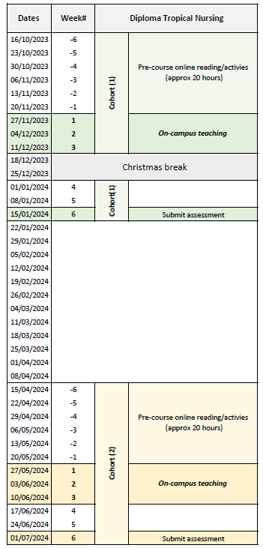

27c | Options
N/A
Part E: Learning, Teaching and Assessment Strategies
28 | Learning, Teaching & Assessment Strategy
The learning and teaching strategy has been designed to foster self-directed learning skills and to enable students to integrate and evaluate their own learning.
Knowledge and Understanding are developed through a combination of the pre-course online module, lectures, case studies, group work, practical laboratory exercises, in-course reading and a simulation exercise. This range of Learning and Teaching approaches provide a rich and encouraging environment in which students will acquire knowledge and skills throughout the duration of the DTN.
Keynote Lectures form the basis of the three-week taught component of the DTN and focus on key topic areas that impact health and wellbeing in low- and middle-income countries. Each lecture will also examine the nurse’s role in a multi-disciplinary team approach.
Case Studies are examples taken from real life to show how health problems and their causes are identified, how they are addressed, and how solutions are found in a well-defined context. They are used to explore how “theory” works in the real world and to learn from empirical experience. This learning method is of particular importance to bridge the gap between theory and practice and to facilitate the application of theory.
Integrated Laboratory practical sessions are used for practising diagnostic and other lab skills with support from highly trained and experienced facilitators. The practical classes enhance the student’s ability to use and interpret common laboratory tests
In-course oral presentations are used to develop communication skills such as the debate on contemporary health issues.
Simulation exercise. This is a practical exercise to consolidate learning and apply skills learnt throughout the course. There are individual and group elements, and every student is provided with a descriptor of a role to assume throughout the simulation exercise.

29 | Assessment Schedule
Formative Assessment:
Pre-course:
A structured online module is made available to students at least 6 weeks in advance of coming to Liverpool and is expected to take approximately 20 hours to complete. A series of optional ‘early bird’ activities are also available. The on-line pre-course activities are based on set readings and reviewed on the first day of the course via an interactive quiz created using ‘TurningPoint’ software and answered using electronic personal response systems (‘clickers’). This enables students to discuss and reflect on their level of professional skills and competencies at the beginning of the programme, to identify gaps and to plan to address these during the programme and also introduces ‘TurningPoint’ as a learning tool.
On-course
Weeks 1 and 2: Thursday evening: students will be required to complete a 20–30-minute formative exercise Friday (in-class) spend up to one hour discussing/reflecting on the exercise.
Week 3: Friday (final day):
- students will engage in a one-hour reflection on the simulation exercise from the previous day using a lessons learnt format. This will be followed by:
- a 2-hour formative exercise on a variety of tropical diseases/interventions using case studies in the form of a ‘Tropical Who Dun It’ (a bit like a murder mystery/Cluedo game) to consolidate knowledge and skills learnt during the previous three weeks.
In addition to the above formative assessments, students will also undertake formative MCQ quizzes in class and will have access to self-assessment resources on-line. Selected laboratory exercises will be assessed formatively in the laboratory handbook in order to give students on-going feedback.
Summative assessment:
Written assignment (100%): Students complete a 2000-word assignment centred on a policy brief.
A policy brief is a stand-alone document that provides an organisation or the reader who is normally a non-specialist, with sufficient evidence-based, research-led information on a single topic to make an informed decision on an intervention. To write a policy brief, students will need to research their topic, state the problem, present and synthesise the research, discuss the implications, make recommendations and a conclusion on the potential impact of the proposed intervention.
Students will be provided with a choice of topics that will relate to the DTN and practice of a nurse or midwife in a low-and middle-income setting. The report is submitted 3 weeks after completion of the taught component and is expected to take approximately 30 hours to complete. During this period, students have access to on-line tutor advice and peer support.

30 | Pass Mark
The pass mark is 50%
31 | Compensation and Resits
Candidates who fail the summative assessment may re-sit the assessment on one further occasion at the discretion of the Board of Examiners.
32 | Marking Descriptors
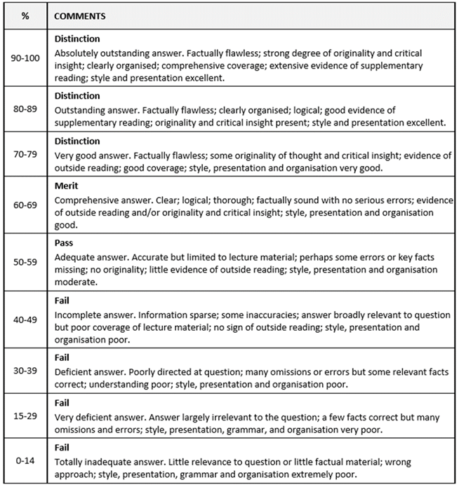

33 | Final Award and Alternative Qualifications
Candidates who achieve a minimum mark of 50% in both the final summative written assessments and an overall mark of 50% or above will be eligible for the award of an LSTM-certified Professional Diploma in Tropical Nursing.
A grade of Merit will be awarded for candidates achieving an overall mark of 60% or above.
A grade of Distinction will be awarded for candidates achieving an overall mark of 70% or above.

Part F: Quality Assurance
34 |  | Examination Process
The DTN Board of Examiners consists of the Chair (either the Director of Education PGT/PGR or Reader in Education) the Programme Director, the Quality Assurance Manager or Senior Quality Assurance Administrator, Programme Administrator, the External Examiner and all members of academic staff who have made a major contribution to the teaching and assessment of the programme.
The Terms of Reference are as follows:
- To monitor methods of assessment against set learning outcomes and programme requirements
- To ensure standards of assessment are maintained
- To assess students’ performance in accordance with regulations
- To reach overall decisions concerning awards
- To make recommendations to the Board of Studies on the conduct and standards of all assessment procedures
The External Examiner is responsible for ensuring that awards made by the LSTM are of a comparable standard with those of similar subjects and awards of other Higher Education Institutions in the United Kingdom, as stated in the Code of Practice on External Examining which is available at: http://www.lstmed.ac.uk/study/quality-manual
Further information on the assessment policies and procedures can be found in the LSTM Professional Diploma Student Handbook.
Information on the purpose, method and schedule of assessment and the timescales for the submission of assessments can be found in the Programme Handbook available on the LSTM student VLE (Virtual Learning Environment) Brightspace.
35 | Student Representation and Feedback
LSTM is committed to receiving and responding to student feedback in order to develop learning and teaching within the institution and to improve the overall quality of the student experience. Students are invited to evaluate the programme on a weekly basis, during focus groups and upon completion via an on-line survey tool. There are also opportunities for ongoing informal feedback via the Director of Studies. Students are encouraged to elect two class representatives to facilitate communication with staff.
Part G: Diversity and Equality of Opportunity and Widening Participation
36 | Diversity and Equality Statement
The programme’s design, structure and content are consistent and compliant with the LSTM Policy on Diversity and Equality of Opportunity. LSTM provides a multicultural, multidisciplinary learning environment in which all students benefit from the opportunity to share diverse experiences and outlooks, supported by staff who are themselves from a variety of national and cultural backgrounds and spend significant periods of time working overseas. LSTM recognises that some students need extra help and guidance in adjusting to a new country, culture or learning environment. Accordingly, we provide a comprehensive range of relevant non-academic student support services. Reasonable adjustments are made to assessment for disabled students in line with the LSTM Code of Practice on Student Support and Welfare.
Part H: Status of Professional, Statutory or Regulatory Body Accreditation
37 | Accreditation Status
n/a

Annex: Modifications
Annex of Modifications made to the Programme - Related List of Modification
Description of Modification (Please include details of any student consultation undertaken or confirm that students’ consent was obtained where this was required) | Major/Minor Modifications | Date Approved by QMC | Date Approved by Mgt Cttee | Cohort Affected

