Part A: Programme Summary Information
1 | Title of Programme | Public Health (Humanitarian Health)
2 | Programme Code | MPH/HH
3 | Entry Award (s):
3a | Entry Award 1 | MPH – 180 Credits:7
3b | Entry Award 2 | PGDip – 120 Credits:7
3c | Entry Award 3 | PGCert – 60 Credits:7
4 | Exit Award (s):
4a | Exit Award 1 | MPH – 180 Credits:7
4b | Exit Award 2 | PGDip – 120 Credits:7
4c | Exit Award 3 | PGCert – 60 Credits:7

5a | Start Date | September 2023 |  | 5b | End Date | September 2024
6 | Frequency of Intake | Annually
7 | Mode of Study | FT
8a | Applicable Framework | LSTM LT REG 01
8b | Exemption Required
8c | Exemption Approved
8d | Details of Exemption
9 | Programme Director | Nara Tagiyeva-Milne
10 | Board of Studies | International Public Health Masters Board of Studies
11 | Board of Examiners | MSc Board of Examiners
12 | External Examiner(s) | Dr. Christine Kim Picozzi
13 | Professional or  Other Body | None
14 | Reference Points | QAA Master’s Degree Characteristics Statement (2020); The UK Quality Code for Higher Education: Frameworks for Higher Education Qualifications of UK Degree-Awarding Bodies (2014)  Priorities of relevant national and international organisations in public health: The Foreign, Commonwealth and Development Office (FCDO), UK; United States Agency for International Development (USAID); World Health Organization (WHO), Association of Schools of Public Health in Africa (ASPHA), The UK Health Security Agency (UKHSA), The UK Faculty of Public Health, The Association of Schools of Public Health in the European Region (ASPHER).
15a | Home/EU Fee |  |  | 15b | Overseas Fee
16 | Additional Costs to the Student | The programme fee covers the cost of a desk-based project based in LSTM. Depending on your previous experience you may be permitted to undertake a lab-based project which will incur an additional fee, called a bench fee which will be approximately £1,500. You may also need to cover the costs of antibody testing and/or vaccinations needed for laboratory projects. Students are not required to pay this additional fee at registration but must have the necessary funds available when they start the programme. LSTM can also help students to arrange a field-based project overseas (typically 4 weeks) and students are encouraged to take this opportunity if your funds allow. Overseas projects will incur costs such as flights accommodation, hiring translators, travel in-country, visas, vaccinations, possibly fees for ethics applications so costs, depending on duration, nature of fieldwork and complexity of project can range from approximately £3,000-£5,000). The School will provide comprehensive insurance for off-site work and cover the cost of this.  While LSTM provides access to the main scientific software packages you will need for your dissertation, occasionally some students use specialist software for their dissertations beyond what LSTM provide and there could be a subscription fee, although often there is a period these can be used for free as a trial. There may additionally be course-relevant and social trips, which are optional for students to attend, and which may have costs attached.

Part B: Programme Aims and Outcomes
17 | Overview of the Programme
This programme prepares students for leadership and equips them to assume an active role in and responsibilities for improving population health in a range of settings. It covers a wide breadth of contemporary issues in international public health and explores approaches to reducing health inequities by enhancing policy and practice based upon sound, evidence-based principles. The programme gives graduates key transferable knowledge and skills in epidemiology, research methods and social science. The Humanitarian Health stream has a specialist focus on humanitarian assistance, examining current policies and practice in the field and exploring public health approaches to responding to the challenges of contemporary humanitarian problems. The Humanitarian Health stream will allow students interested in Public Health to further specialise and develop skills essential for humanitarian health leaders. The stream focuses on the particular challenges, constraints & requirements of working in the humanitarian sector, and allows students to explore themes relevant to this field such as working in conflict or unsafe situations, working with refugees and displaced population and understanding the increasing interaction between humanitarian crises and climate change.
Following the taught component, students on this stream complete a research dissertation project on a topic relevant to humanitarian health either overseas or locally, and could be desk based or field work. The programme is underpinned by LSTM’s mission to reduce the burden of sickness and mortality in disease endemic countries through the delivery of effective interventions which improve human health and are relevant to the poorest communities. The programme has been developed around a series of Public Health competencies derived from the international reference points (see Reference Points above) and mapped to these competencies (see Appendix 1).
18 | Aims of the Programme
No. | Specific Aim |  | Entry Award
1 | To equip students with public health (Level 7) knowledge, skills and analytical tools to recognise, evaluate and analyse public health challenges at relevant local, national and global levels. |  | All Awards
2 | To underpin students’ abilities to contribute to developing high quality, effective interventions that address health inequities, strengthen health systems and improve health in resource poor settings. |  | All Awards
3 | To provide students with knowledge and skills that will help to protect populations against contemporary and emerging threats or hazards and enable them to influence the wider social, environmental and structural determinants of health. |  | All Awards
4 | To enhance students’ epidemiological, and other qualitative and quantitative research skills, so they can critically appraise evidence, plan and implement evidence-based interventions, undertake research, and monitor and evaluate public health activities. |  | MPH only
5 | To enable students to develop as resilient, effective public health leaders with excellent communication skills and high professional standards who have the ability and motivation to continue learning and work effectively and efficiently within global health systems. |  | All Awards
6 | To facilitate students’ exploration of approaches to responding to humanitarian challenges and provide students with the skills, knowledge and understanding of humanitarian issues needed to practice at a senior level in organisations involved in the prevention of and response to humanitarian crises. |  | All Awards
19 Skills and Other Attributes
No. |  |  | Skill/Attribute |  | Module(s) | Mode of Assessing
1 |  |  | To identify issues, evaluate, critically appraise and interpret evidence and undertake basic research |  | 702, 700, 732, 703, 727, 726 | MCQ exam, critical reflection, scientific report, research proposal, research report; critical analysis, epidemiological report, essay, group presentation, individual reflection
2 |  |  | To communicate concepts, arguments, evidence and public health strategies effectively to a variety of audiences using a range of media and technologies |  | 700, 732, 718, 713 | Scientific report, research proposal, research report, critical review, group presentation; written report
3 |  |  | To solve problems and make decisions through the creative application of knowledge to protect population health in complex and unpredictable situations |  | 702, 732, 718, 726, 727 | MCQ exam, critical reflection, research report, critical review, group presentation epidemiological report, essay, group presentation, individual reflection
4 |  |  | To negotiate effectively and work in partnership with a wide range of stakeholders to improve population health, health services and systems |  | 700, 713, 726, 718, 729 | Scientific report, research proposal, group presentation, individual report, essay, individual reflection, critical review, policy brief, poster presentation
5 |  |  | To apply numerical and IT skills with confidence and accuracy |  | 702, 727 | MCQ exam, critical reflection, epidemiological report
20 |  | Subject Based Learning Outcomes
A |  | Knowledge and Understanding. Upon successful completion of the programme, a student should have developed and be able to demonstrate:
No. |  | Learning Outcome |  | Module(s) |  | Mode of Assessing | Entry Award
A1 |  | Critical knowledge and understanding of major global health threats, with a focus on the determinants of health in resource poor settings |  | 703, 713, 718, 729, 726 |  | Critical analysis, group presentation, individual report, critical review, policy brief, poster presentation, essay, individual reflection | All Awards
A2 |  | Mastery of the fundamental principles of epidemiology, public health and related research methods |  | 702, 732, 703, 713, 727 |  | MCQ exam, critical reflection, research report, critical analysis; group presentation, individual report, epidemiological report | All Awards
A3 |  | Critical knowledge of the history, politics, policies and strategies that influence health |  | 703, 718, 729, 726 |  | Critical analysis, critical review, group presentation, policy brief, poster presentation, essay, individual reflection | All Awards
A4 |  | An understanding of how health systems and services respond to health issues, including financing. |  | 713 |  | Group presentation, individual report | All Awards
A5 |  | Critical knowledge and understanding of human rights, legal frameworks, and professional values |  | 700, 718, 729 |  | Scientific report, research proposal, critical review, group presentation, policy brief, poster presentation | All Awards
A6 |  | Critical knowledge and understanding of the impact of humanitarian emergencies on health and wellbeing |  | 718 |  | Critical review, group presentation | All Awards
B |  | Cognitive Skills. Upon successful completion of the programme, a student should be able to:
No. |  | Learning Outcome |  | Module(s) |  | Mode of Assessing | Entry Award
B1 |  | Critically analyse, synthesise and evaluate information from a variety of sources to assess population health risks and wellbeing status |  | 702, 732, 703, 713, 727, 726, 729, 700 |  | MCQ exam, reflection, research report, critical analysis, group presentation, individual report, epidemiological report, essay,  policy brief, poster presentation, critical review, scientific report, research proposal | All Awards
B2 |  | Use a holistic, problem-solving approach to analyse health issues and offer creative solutions to improve health |  | 700, 702, 718, 726, 729, 732 |  | Scientific report, research proposal, MCQ exam, critical reflection, critical review, group presentation, Essay, individual reflection, policy brief, poster presentation, research report | All Awards
B3 |  | Apply critical thinking skills to the development and delivery of public policy for health and wellbeing |  | 700, 703, 718, 726 |  | Scientific report, research proposal, critical analysis, critical review, group presentation, essay, individual reflection | All Awards
B4 |  | Critically appraise literature and other evidence to inform the development, monitoring and evaluation of interventions to improve health and health services |  | 700, 732, 713, 726, 729 |  | Scientific report, research proposal, critical analysis, critical review, group presentation, essay, group presentation, individual reflection | All Awards
B5 |  | Learn independently through continuous professional development |  | 700, 713 |  | Scientific report, research proposal, group presentation, individual report | All Awards
C |  | Practical/Professional Skills. Upon successful completion of the programme, a student should be able to:
No. |  | Learning Outcome |  | Module(s) |  | Mode of Assessing | Entry Award
C1 |  | Manage time and resources effectively |  | 700, 713, 732 |  | Scientific report, research proposal, group presentation, individual report, research report | All Awards
C2 |  | Take a leadership role in managing change and contribute effectively in responding to population health issues |  | 700, 703, 713, 718, 726 |  | Scientific report, research proposal, critical analysis, group presentation, individual report, critical review, group presentation, essay, group presentation, individual reflection | All Awards
C3 |  | Apply appropriate governance frameworks to engage effectively with communities to improve health and wellbeing |  | 700, 718 |  | Scientific report, research proposal, critical review, group presentation | All Awards
C4 |  | Communicate and negotiate effectively with colleagues and the public, and act as an advocate to improve health for all, but especially for disadvantaged groups |  | 700, 713, 729, 727, 726 |  | Scientific report, research proposal, group presentation, individual report, policy brief, poster presentation, epidemiological report, essay, group presentation, individual reflection | All Awards
C5 |  | Design and undertake research investigations in a responsible and ethical manner, including the use of appropriate technology. |  | 702, 700, 727, 732 |  | MCQ exam, critical reflection, scientific report, research proposal, epidemiological report, research report | All Awards
21 | Career Opportunities
Throughout the world, many career opportunities exist in the field of Public Health. PH responses to humanitarian emergencies have been highlighted by the Covid-19 pandemic, the war in Syria, the refugee camps & mass migration from the area, natural disasters e.g. earthquakes & tsunamis, the Ebola Outbreak, influenza & MERS.
People with PH skills & knowledge of the humanitarian sector are highly sought after. Past alumni of this course typically gain employment in UN Agencies, national/international NGOs, aid organisations, health ministries/departments, or universities.
As well as careers noted above, Humanitarian Health training makes graduates suitable to work in conflict related situations, with victims of displacement or persecution (in the global south & north) & with those whose livelihoods are impacted by natural & man-made disasters. MPH(I)-(HH) stream will enhance the versatility of contexts graduates are familiar with and will increase their employability with for and not-for profit agencies.

Part C: Entrance Requirements

22 | Academic Requirements | Open to health professionals and graduates in health or related disciplines. In addition, candidates with qualifications such as law, psychology, education, social work/care, finance, business management, engineering, philosophy, anthropology, sociology, history, architecture and politics/international relations are welcome, particularly if they have relevant health related experience. Non-graduates with considerable work experience in the health sector of low or middle-income countries and evidence of continued academic development through appropriate in-service training will also be considered. Medical students who have completed at least three years of study and wish to intercalate are also accepted onto the programmme.
23 | English Language Requirements | The programme is taught in English. Applicants whose first language is not English must normally provide evidence of an IELTS (International English Language Testing System) score of at least 6.5 with a minimum of 5.5 in all learning components, or a TOEFL (Test of English as a Foreign Language) score of at least 88 for the Internet-based Test (iBT), with minimum scores of 21 for Listening and Writing, 22 for Reading and 23 for Speaking. Tests should be within their validity period of 2 years. Other English Language Tests and country specific English Language qualifications are also accepted - a full list with details of levels required can be found on the LSTM website (http://www.lstmed.ac.uk/study/how-to-apply/english-language-requirements). Applicants who have recently completed a degree level qualification taught in a majority English speaking country (as defined by UK Visas and Immigration (UKVI) may also be accepted at the discretion of the Director of Studies.
24 | Recognition of Prior Learning | All programmes of study will permit entry with credit attributed to previous certificated study up to a total of one third of the credits required to be awarded a Master's degree, Postgraduate diploma, Postgraduate certificate or Postgraduate award.
25 | Work Experience | Candidates generally require professional or voluntary experience in health or a related area in a low- or middle-income country. Candidates without this experience are eligible, provided they can demonstrate an understanding and engagement in international public health issues or evidence of appropriate training. A protocol for assessing this has been developed and approved by the admissions team and senior management.
26 | Other Requirements | Basic computing skills (e.g. word processing; emailing; webcam; printing)

Part D: Programme Structure

27a | Overview
The MPH (Humanitarian Health) programme is modular in structure with each taught module worth 20 credits and the dissertation project 60 credits. Each module (20 credits) represents 200 hours of student learning including assessments and self-directed study.
The MPH (Humanitarian Health) is offered within a dynamic research-led environment and its content is informed by the cutting-edge research activities of the academic staff. It is designed to enable the professional development of the student, to be relevant to students from both the UK and overseas and to promote approaches to study that will enable graduates to continue their learning into the future.
Students can carry out a fieldwork-based dissertation project overseas, in a local setting or can conduct a literature-based project that does not involve travelling abroad. All types of project have the key aims of developing the students’ skills in formulating a research question, designing and implementing a research project and critically interpreting and presenting the findings. The timing of modules across the academic year recognises the financial and time constraints faced by LSTM students, many of whom are from outside UK.
The modules available to students following the programme are shown in Section 27b. Required modules are necessary to achieve the programme learning outcomes and must be taken by all students following the programme. The optional modules listed have been identified as most suitable for contributing to the attainment of the programme learning outcomes.

27b | Timetable
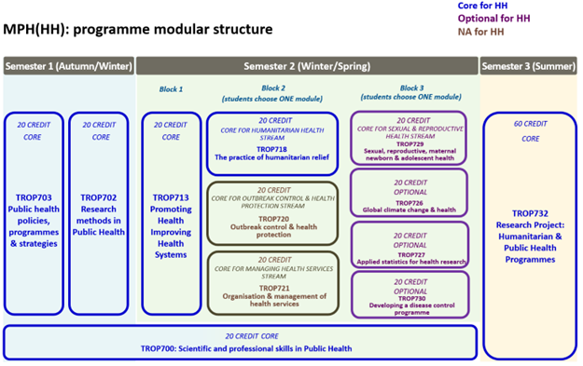

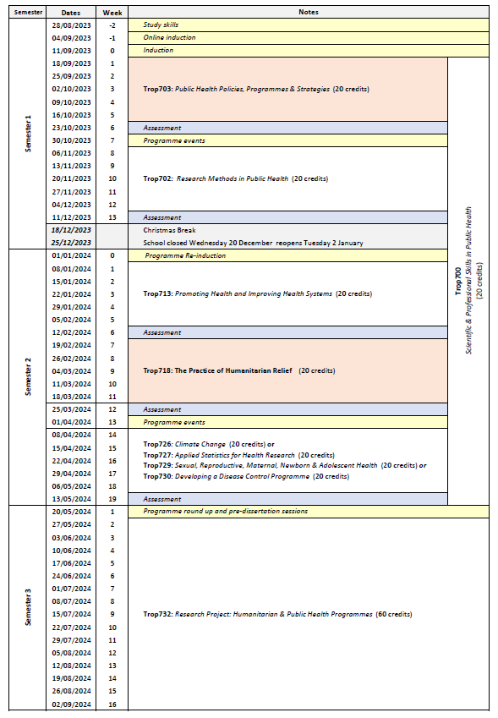

Appendix 1 MPH programme mapping to public health competencies.
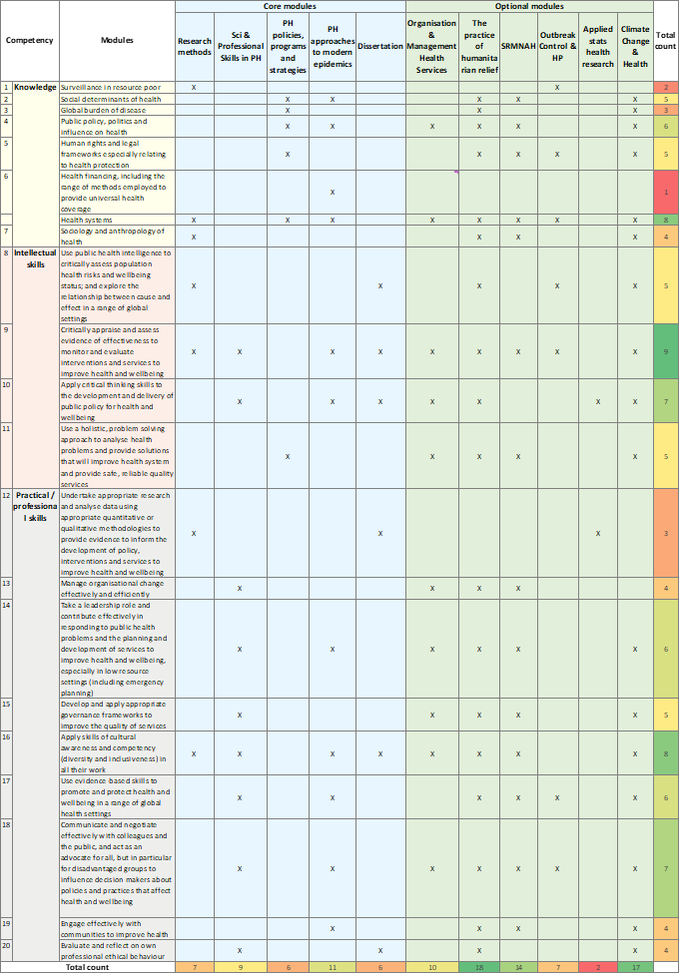

27c | Options
Semester 2 (Block 3)
Trop726 Global Climate Change and Health
Trop727 Applied Statistics for Health Research
Trop729 Sexual, Reproductive, Maternal, Newborn and Adolescent Health
Trop730 Developing a Disease Control Programme

Part E: Learning, Teaching and Assessment Strategies
28 | Learning, Teaching & Assessment Strategy
The L&T strategy is designed to help all students express their full potential through a combination of student-centered blended learning approaches. Lectures highlight key points and provide participants with a core knowledge base in public health. Students are expected to enhance this core knowledge and become reflective independent learners through guided enquiry-based self-study and use of on-line materials. To develop cognitive and intellectual skills, the programme involves discussion of key issues, analysis and interpretation of resource material and practice in applying concepts and solving public health problems. Group work develops students’ abilities to work co-operatively, promotes creativity, provides opportunities to reflect critically and enables participants to take more responsibility for their own learning, as well as learn from each other. Students can also take advantage of lectures and seminars given by the many distinguished researchers and policy makers who regularly visit LSTM. The L&T methods adopted reflect the diversity of the LSTM student population and an ethical and culturally sensitive approach is emphasised throughout.
The assessment strategy is designed to encourage the student to develop and improve on a range of skills, including synthesising and evaluating information, academic writing, numerical and IT skills, team-working, presentation skills, and time management. Both formative and summative assessment approaches are used. General assessment procedures, assessment criteria and regulations with respect to late submission are communicated to the students in the LSTM Masters’ Student Handbook. Students are directed to the relevant module area in Brightspace for information relating to specific assignments.

29 | Assessment Schedule
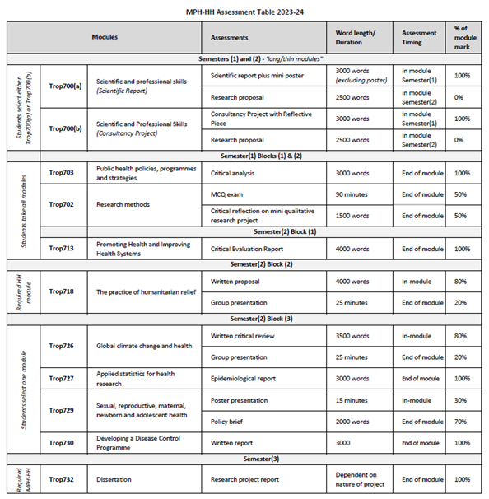
30 |  | Pass Mark
The pass mark for each module is 50%.
31 |  | Compensation and Resits
Compensation
Where the overall average mark in all taught modules is 50% or above, a mark of 40-49% in one module of 20 credits will be deemed compensatable. The compensation rule does not apply to postgraduate award or to stand-alone modules. Marks for modules passed by the compensation rule will be recorded as a pass mark of 50%.
Re-sits
Students who fail one or more modules at the first attempt will normally be offered one reassessment opportunity for each failed component. Reassessment will normally take place in the defined reassessment period, but where this is not possible, within twelve months of the failed assessment. A failed research project may be submitted on one further occasion only, within one year of the original date of submission. Marks achieved through reassessment will be capped at 50% for the purpose of calculating the overall average mark and determining classification for an award. The actual mark achieved through reassessment will be the mark recorded on the transcript. Students will not be permitted a reassessment opportunity for any module or assignment they have passed, with the aim of improving the mark, except in the case of extenuating circumstances. Further information relating to the re-sitting of examinations, including timing of re-sits, can be found in the LSTM Masters Student Handbook.
32 |  | Marking Descriptors
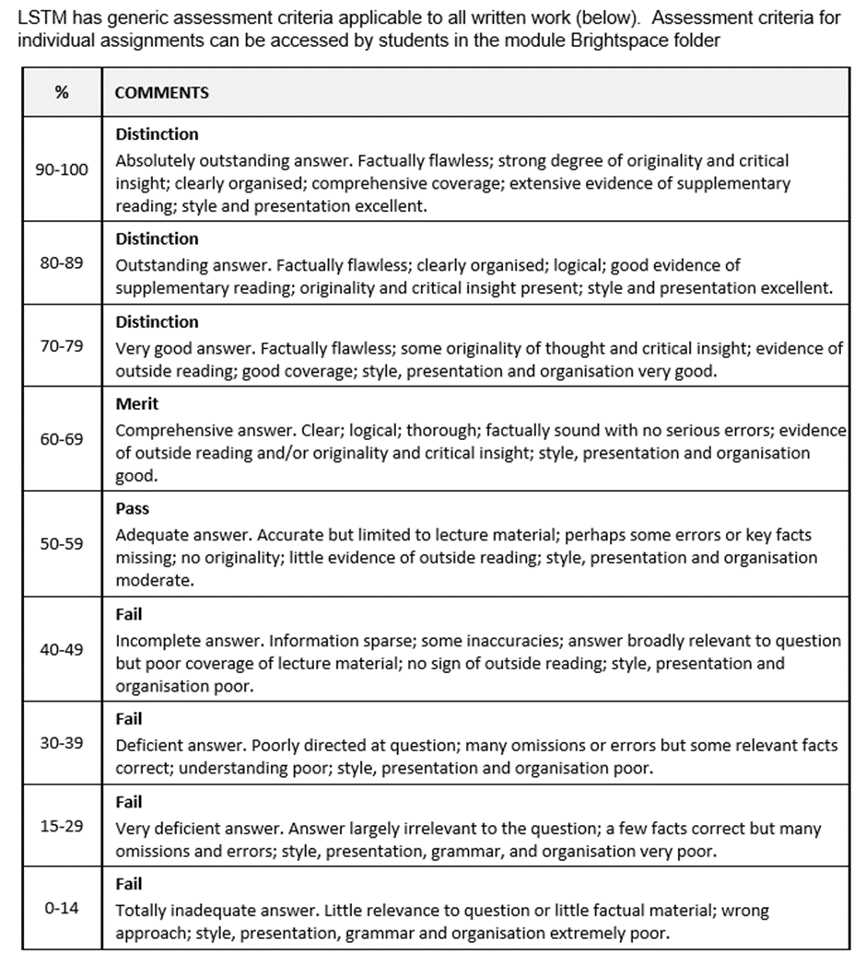

33 | Final Award and Alternative Qualifications
Final Award
Students who attend for a minimum period of 12 months of full-time study, and who achieve a minimum of 180 credit points at FHEQ level 7, and successfully complete a dissertation/research project worth 60 credits will be eligible for the award of a Master’s degree. To be awarded the Master of Public Health ((Humanitarian Health ), credits must include all core modules and a dissertation in Public Health applied in the area of humanitarian health.
Students who attend for a minimum period of 30 weeks of full-time study, and who achieve a minimum of 120 credit points at FHEQ level 7, will be eligible for the award of a Postgraduate Diploma. A Postgraduate Diploma shall be comprised either of all taught modules if an entry award, or may include the 60 credit research project module if an exit award. To be awarded the Postgraduate Diploma Public Health (Humanitarian Health), as an entry award, candidates must achieve 120 credits from the taught component of the Master of Public Health programme to include Trop718: The Practice of Humanitarian Relief and two other core modules, with the exception of Trop700: Scientific and Professional Skills. An exit award that includes the dissertation project should also include Trop718: The Practice of Humanitarian Relief.
Students who attend for a minimum period of 15 weeks full-time study, and who achieve a minimum of 60 credit points at FHEQ level 7, will be eligible for the award of a Postgraduate Certificate. To be awarded the Postgraduate Certificate Public Health (Humanitarian Health), the credits achieved must include Trop718: The Practice of Humanitarian Relief and two other core modules, with the exception of Trop700: Scientific and Professional Skills.
A mark of Merit or Distinction will be awarded according to the criteria below. A Merit or Distinction may be awarded if a student has failed and then passed on re-sit any credit that counts towards the final award during the relevant period of study at LSTM. However, marks are capped at 50% for the purposes of calculating the award. Marks achieved in modules which are passed under the compensation rule may also be counted towards a Merit or Distinction. It should be noted that students who register on the MPH-HH, but who exit with a lower award, will be eligible for a Merit or Distinction for the lower award, provided the student meets the criteria outlined below:
For a Master’s degree with Distinction a student must achieve:
- An overall average of at least 70% across all modules, and
- A Distinction grade for the dissertation; or
- a Distinction grade for the average of the taught modules.
For a Postgraduate Diploma with Distinction a student must achieve:
- An overall average mark of at least 70% in 120 credits of modules, which can be made up of the taught modules alone or taught modules and the dissertation (120 Credits).
For a Postgraduate Certificate with Distinction a student must achieve:
- an overall average mark of at least 70% in 60 credits of taught modules
For a Master’s degree with Merit a student must achieve:
- An overall average of at least 60% across all modules, and
- A Merit grade for the dissertation; or
- a Merit grade for the average of the taught modules.
For a Postgraduate Diploma with Merit a student must achieve:
- An overall average mark of at least 60% in 120 credits of modules, which can be made up of the taught modules alone or taught modules and the dissertation (120 Credits).
For a Postgraduate Certificate with Merit a student must achieve:
  - an overall average mark of at least 60% in 60 credits of taught modules
Average marks falling up to 2% below any grade boundary are deemed to be borderline cases. In these cases, the award is determined by consideration of the profile of marks across all taught modules. To be awarded the higher grade, at least 50% of the taught credits must be at the higher grade.
Students who take modules on a stand-alone basis will become eligible for an award with Distinction or Merit where they:
    - Subsequently register for a programme of study which leads to an award and successfully complete the required credit through the study of appropriate modules as defined in the programme specification or accumulate sufficient credit for an unnamed award in accordance with an approved programme of study.
Where a student has successfully completed modules which exceed the required credit for the award the calculation of the overall average mark and determination of classification will be based on the modules with the higher marks.
Criteria for the award of an alternative qualification
If a student fails to meet the criteria for the award of a Master’s degree or a Postgraduate Diploma, or is unable to complete the programme he or she registered for, they may be eligible for the award of one of the following as an exit qualification:
- Postgraduate Diploma Public Health (Humanitarian Health) will be awarded to students who have previously registered for the Master’s degree provided that the student has achieved a minimum of 120 credits. The 120 credits may include dissertation credits to the value of 60 credits. To qualify for a Postgraduate Certificate Public Health (Humanitarian Health), the credits achieved must include Trop718: The Practice of Humanitarian Relief and two other core modules, with the exception of Trop700: Scientific and Professional Skills. Students who exit without having achieved the core modules may be eligible for an unnamed Postgraduate Diploma.
- Postgraduate Certificate Public Health (International) will be awarded to students who have previously registered for the Master’s Degree or the Postgraduate Diploma of 60 credits. The credit may not include any dissertation credits. To qualify for the Postgraduate Certificate Public Health (Humanitarian Health) the credits achieved must include Trop718: The Practice of Humanitarian Relief and two other core modules, with the exception of Trop700: Scientific and Professional Skills. Students who exit without having achieved the core modules may be eligible for an unnamed Postgraduate Certificate.

Part F: Quality Assurance
34 | Examination Process
The Masters Board of Examiners consists of the LSTM Director (Chair), Dean of Education, Academic Registrar (Secretary), the External Examiners from all LSTM Master’s programmes and all members of academic staff who have made a major contribution to the teaching and assessment of the programmes.
The Terms of Reference are as follows:
- To monitor methods of assessment against set learning outcomes and programme requirements
- To ensure standards of assessment are maintained
- To assess students’ performance in accordance with regulations
- To reach overall decisions concerning awards
- To make recommendations to the Board of Studies on the conduct and standards of all assessment procedures
External Examiners are responsible for ensuring that awards made by LSTM are of a comparable standard with those of similar subjects and awards of other Higher Education Institutions in the United Kingdom, as stated in the Code of Practice on External Examining of Taught Programmes which is available at: http://www.lstmed.ac.uk/study/quality-manual
Further information on the assessment policies and procedures can be found in the LSTM Masters Student Handbook, including:
- The penalties for the late submission of assessments
- The rules relating to plagiarism and collusion
- Ill-health and other special factors
Information on the purpose, method and schedule of assessment and the timescales for the submission of assessments can be found in the Programme Handbook (available on the LSTM student intranet) and on the Brightspace programme page.

35 | Student Representation and Feedback
LSTM is committed to receiving and responding to student feedback in order to develop learning and teaching within the institution and to improve the overall quality of the student experience. Students are encouraged to evaluate individual modules and the programme via an online survey tool. The survey results are reported at Board of Study (BoS) meetings, together with any additional feedback from the student representatives. Regular focus groups will be held and there are opportunities for informal feedback via tutors and module convenors.
Students will be formally represented within the LSTM committee structure:
- The Staff Student Liaison Committee (SSLC) meets 3 times a year and includes an elected representative from each programme, including any programme streams. The minutes of the SSLC are received by the Learning & Teaching Committee (L&TC). The membership of the SSLC, its terms of reference and the manner in which it conducts its business conform to the requirements of the Code of Practice on Student Engagement and Enhancing the Student Experience - http://www.lstmed.ac.uk/study/quality-manual
- (b) Each Master’s programme has a Board of Studies (BoS), which oversees its planning, operation, management and development. Membership of the BOS consists of the Director of Studies for the Programme, the Academic Registrar, elected student representatives, Registry staff supporting the programme, Convenors of Modules and those making a significant contribution to the programme.
Students play an active role in the work of the BoS, with the exception of reserved and confidential business. The minutes of all Boards of Studies are received by the L&TC.
- (c) The Quality Management Committee (QMC) oversees the academic standards and quality assurance and enhancement of all taught programmes, ensuring that LSTM’s quality assurance processes are fully informed by external expectations including the UK Quality Code for Higher Education. Two students from across all programmes serve as full members of the QMC. The QMC reports on academic quality assurance and enhancement issues to the L&T Committee. The Committee meets a minimum of four times per academic year and is responsible for:
- Approving, monitoring and reviewing programmes and modules
- Approving recommendations for the appointment of external examiners for LSTM programmes.
- Monitoring the progress of actions raised by External Examiners
- Developing, monitoring and reviewing the peer observation system

Part G: Diversity and Equality of Opportunity and Widening Participation
36 | Diversity and Equality Statement
The programme’s design, structure and content are consistent and compliant with the Diversity and Equality of Opportunity Policy. LSTM provides a multiracial, multidisciplinary learning environment in which all students benefit from the opportunity to share diverse experiences and outlooks, supported by staff who are themselves from a variety of national and cultural backgrounds and spend significant periods of time working overseas. LSTM provides a comprehensive range of relevant non-academic student support services. The Personal Tutor System aims to provide students with advice and support in matters related to academic work and to enable the development of independent study habits suitable for higher education. Reasonable adjustments are made to assessments for disabled students in line with the Code of Practice on Student Support and Welfare.

Part H: Status of Professional, Statutory or Regulatory Body Accreditation
37 | Accreditation Status
Not applicable

Annex: Modifications
Annex of Modifications made to the Programme - Related List of Modification
Description of Modification (Please include details of any student consultation undertaken or confirm that students’ consent was obtained where this was required) | Major/Minor Modifications | Date Approved by QMC | Date Approved by Mgt Cttee | Cohort Affected

