Part A: Programme Summary Information

1 | Title of Programme | Tropical Health and Infectious Disease Research
2 | Programme Code | MRes/THIDR
3 | Entry Award (s):
3a | Entry Award 1 | MRes – 180 Credits:7
3b | Entry Award 2 | N/A
3c | Entry Award 3 | N/A
4 | Exit Award (s):
4a | Exit Award 1 | MRes – 180 Credits:7
4b | Exit Award 2 | PGCert – 60 Credits:7
4c | Exit Award 3 | N/A

5a | Start Date | September 2023 |  | 5b | End Date | September 2024
6 | Frequency of Intake | Annual
7 | Mode of Study | FT
8a | Applicable Framework | LSTM LT REG 01
8b | Exemption Required
8c | Exemption Approved
8d | Details of Exemption
9 | Programme Director | Anne Wilson
10 | Board of Studies | MRes Board of Studies
11 | Board of Examiners | MSc Board of Examiners
12 | External Examiner(s) | tbc
13 | Professional or  Other Body | None
14 | Reference Points | Priorities of relevant national and international organisations in global health (Foreign Commonwealth & Development Office, UK; United States Agency for International Development; World Health Organisation); QAA Master’s Degree Characteristics Statement (2020); The Frameworks for Higher Education Qualifications of UK Degree-Awarding Bodies (2014)
15a | Home/EU Fee |  |  | 15b | Overseas Fee
16 | Additional Costs to the Student | The programme fee covers the cost of a desk-based, laboratory-based or field-based research project. Some projects (numbers may be limited) will include an element of overseas data collection, in this case flights, local travel, field staff and equipment / consumable costs will be covered, up to an agreed maximum budget (£4000). You may also need to cover the costs of antibody testing and/or vaccinations needed for laboratory projects. Students are not required to pay this additional fee at registration but must have the necessary funds available when they start the programme. As with other programmes, if students choose an overseas project there will be additional costs to cover (see below). There may additionally be course-relevant and social trips, which are optional for students to attend and which may have costs attached.

Part B: Programme Aims and Outcomes
17 | Overview of the Programme
The overarching scope of the MRes programme in Tropical Health and Infectious Disease Research is to give students a fully immersive experience of what it means to do scientific research. The MRes will provide training and practical research experience covering a breadth of research areas including basic, clinical and public health research with a focus on low resource settings. In the first part of the course, students will receive advanced and research-informed contemporary learning specific to their research interests giving them a grounding in important research themes and research methods, spanning basic research (e.g. parasitology, microbiology, host-pathogen interactions, vector biology), clinical research (disease diagnosis, management and control) and public health research (e.g. epidemiology, disease control, health determinants, history of global health, health systems, health policy, programme management). Subsequently, students will then be given the freedom to become part of an active research group, with an opportunity to contribute, with the input of their supervisor, to the design and execution of a research project with the goal of generating and/or analysing data relevant to the field of tropical health and infectious disease research. A range of research projects will be offered including lab-, desk-, clinical- or field-based projects. At its conclusion students should have a unique insight to the process of research and an informed view of suitability and preferences for different aspects of academic, industrial or operational research.
In addition to this direct research experience students will be given a series of tasks aimed at developing key transferable skills such as data analysis and presentation, an ability to create and defend scientific argument. Many of these tasks are performed as groupwork to nurture collaborative skills and build an identity of cohort among students.
Teaching and research opportunities will be delivered by an internationally diverse team of research-active experts in their disciplines, covering basic biological research, through to clinical sciences and public health. Given LSTM’s unique focus on problems of public health in predominantly tropical and sub-tropical regions of limited resource, the majority of the programme’s research focus will be on public health problems in these settings, with research projects being offered either in Liverpool or overseas (limited number), with opportunities to engage with professional and industrial bodies in global health as part of this process.
18 | Aims of the Programme
No. | Specific Aim |  | Entry Award
1 | Develop students’ experience in generating hypotheses, identifying, conceptualising and framing research questions, conducting experiments, critically analysing data, discussing findings and identifying conclusions with relevance to basic, clinical or public health research in low resource settings in the tropics and subtropics. |  | All Awards
2 | Provide students with an extensive and immersive experience of what it means to perform academic research in science and thus make more informed choices about future careers in academia, industry, NGOs or other sectors. |  | All Awards
3 | Evaluate current issues and priorities with regard to tropical health and infectious disease research in tropical and resource-limited regions of the world. |  | All Awards
4 | To equip students with transferable abilities and skills in critical and reflective thinking, effective, independent and collaborative team working, problem-solving, ethical project planning and management, and confident communication within a range of environments/contexts. |  | All Awards
19 Skills and Other Attributes
No. |  |  | Skill/Attribute | Module(s) |  | Mode of Assessing
1 |  |  | To communicate complex principles, knowledge, and strategies confidently and effectively, via a range of media including oral, visual and written, to a variety of relevant audiences. | All modules |  | Written assessments and oral presentations
2 |  |  | To apply statistical and scientific computing skills with confidence and accuracy. | All modules |  | Summative Feedback on Research Reports; Formative Feedback on Data Analysis Skills Workshop
3 |  |  | To work effectively both independently and in collaboration with others. | All modules |  | Indirect contribution to all assessments; mock grant proposal exercise and group journal club (‘Academic and Professional Skills’)
4 |  |  | To manage independent learning. | All modules |  | Indirect contribution to all assessments
5 |  |  | To apply skills in effective project and time management to set goals, prioritise activities and meet deadlines. | All modules |  | Assessed indirectly in all modules through timely submission of assessments
20 |  | Subject Based Learning Outcomes
A |  | Knowledge and Understanding. Upon successful completion of the programme, a student should have developed and be able to demonstrate:
No. |  | Learning Outcome |  |  | Module(s) | Mode of Assessing | Entry Award
A1 |  | (Tropical Biology Focus)  Define and critically appraise current issues and priorities in the fields of biology, host-pathogen interaction, molecular and cellular biology, epidemiology, and control, of pathogens, vectors of disease, and organisms of importance to public health with particular emphasis on tropical and resource-limited regions of the world. |  |  | 707, 705, 731 | Written/practical examination; Written report; Dissertation and viva voce | MRes
A1 |  | (Public Health Focus)  Critically appraise public health approaches, policies and strategies in a variety of social, epidemiological, cultural, economic and political settings in tropical and resource-limited regions of the world and understand approaches to developing policy and enhancing practice based upon sound, evidence-based principles. |  |  | 703, 702, 731 | Critical analysis; MCQ Examination, Critical reflection; Dissertation and viva voce | MRes
A1 |  | (Tropical Medicine Focus)  Apply appropriate skills related to the diagnosis, management and control of tropical parasitic, bacterial, viral and fungal infections of children and adults as well as interplay with non-communicable diseases in a variety of regional and resource settings. |  |  | 711, 705/702,731 | Poster presentation, SAQ Examination; Written report/MCQ Exam, critical reflection; Dissertation and viva voce | MRes
A2 |  | Review, identify and comprehensively describe appropriate research methods to answer research questions with relevance to public health concerns in low resource settings in the tropics and sub-tropics. |  |  | All modules | Poster presentation, Group presentation, group grant proposal, critical analysis, written/practical examination, SAQ examination; MCQ examination, written report, dissertation and viva voce | MRes
A3 |  | Critically appraise and evaluate current methods, findings, and research developments related to public health concerns in low resource settings in the tropics and sub-tropics. |  |  | All modules | Module formative and summative assessments, dissertation and viva voce | MRes
B |  | Cognitive Skills. Upon successful completion of the programme, a student should be able to:
No. |  | Learning Outcome |  |  | Module(s) | Mode of Assessing | Entry Award
B1 |  | Critically analyse, synthesise and evaluate information from a variety of sources. |  |  | All modules | Poster presentation, Group presentation, group grant proposal, critical analysis, written/practical examination, SAQ examination; MCQ examination, written report, dissertation and viva voce | MRes
B2 |  | Apply subject knowledge and understanding in a variety of contexts to analyse and reach evidence-based conclusions on complex situations, problems and opportunities. |  |  | All modules | Poster presentation, Group presentation, group grant proposal, critical analysis, written/practical examination, SAQ examination; MCQ examination, written report, dissertation and viva voce | MRes
B3 |  | Review the principles and values of ethical practice with regard to the design and practice of research studies, consent and confidentiality in the collection and presentation of data, and publication. |  |  | All modules | Poster presentation, Group presentation, group grant proposal, critical analysis, written/practical examination, SAQ examination; MCQ examination, written report, dissertation and viva voce | MRes
B4 |  | Demonstrate creativity, innovation and originality in the application of knowledge. |  |  | All modules | Poster presentation, Group presentation, group grant proposal, critical analysis, written/practical examination, SAQ examination; MCQ examination, written report, dissertation and viva voce | MRes
C |  | Practical/Professional Skills. Upon successful completion of the programme, a student should be able to:
No. |  | Learning Outcome |  |  | Module(s) | Mode of Assessing | Entry Award
C1 |  | Identify a hypothesis, formulate a research question, devise an appropriate research strategy and take a systematic approach to project planning and management. |  |  | All modules | Poster presentation, Group presentation, group grant proposal, critical analysis, written/practical examination, SAQ examination; MCQ examination, written report, dissertation and viva voce | MRes
C2 |  | Perform research using ethically appropriate techniques within the methods and data collection. |  |  | All modules | Poster presentation, Group presentation, group grant proposal, critical analysis, written/practical examination, SAQ examination; MCQ examination, written report, dissertation and viva voce | MRes
C3 |  | Effectively manage, analyse, and critically interpret data collected in the laboratory, field or in silico. |  |  | All modules | Poster presentation, Group presentation, group grant proposal, critical analysis, written/practical examination, SAQ examination; MCQ examination, written report, dissertation and viva voce | MRes
C4 |  | Critically appraise and select effective means of reporting and communicating research questions, strategies and findings within differing contexts and environments. |  |  | All modules | Poster presentation, Group presentation, group grant proposal, critical analysis, written/practical examination, SAQ examination; MCQ examination, written report, dissertation and viva voce | MRes
21 | Career Opportunities
Graduates are competitively placed to begin PhD programmes or seek employment within academic or private sector research programmes. Alumni of LSTM hold prominent positions in health ministries, universities, hospitals, and international organisations throughout the world. In terms of student development, the goal of the MRes in Tropical Health and Infectious Disease Research is the formation of highly skilled, independent researchers equipped to pursue high-level research or applied careers. Transferable skills developed during the MRes, particularly critical analysis skills will also set students in good stead to work for a diverse range of employers including NGOs and bilateral and multilateral organisations.

Part C: Entrance Requirements

22 | Academic Requirements | Open to graduates with an Honours degree (minimum 2.i or equivalent) in the biological sciences or a medical/veterinary degree. Overseas candidates with other qualifications may be accepted, particularly if they have the relevant experience through working in an appropriate field for a number of years. Medical or Veterinary students who have completed at least three years of study and wish to intercalate are also accepted onto the programme.
23 | English Language Requirements | The programme is taught in English. Applicants whose first language is not English must normally provide evidence of an IELTS (International English Language Testing System) score of at least 6.5 with a minimum of 6.5 in all learning components, or a TOEFL (Test of English as a Foreign Language) score of at least 88 for the Internet-based Test (iBT), with minimum scores of 21 for Listening and Writing, 22 for Reading and 23 for Speaking. Tests should be within their validity period of 2 years. Other English Language Tests and country-specific English Language qualifications are also accepted – a full list with details of levels required can be found on the LSTM website (http://www.lstmed.ac.uk/study/how-to-apply/english-language-requirements). Applicants who have recently completed a degree-level qualification taught in a majority English speaking country (as defined by UK Visas and Immigration (UKVI)) may also be accepted at the discretion of the Director of Studies.
24 | Recognition of Prior Learning | All programmes of study will permit entry with credit attributed to previous certificated study up to a total of one third of the credits required to be awarded a Masters Degree, Postgraduate Diploma, Postgraduate Certificate or Postgraduate Award.
25 | Work Experience | Non-graduates with considerable satisfactory work experience and evidence of appropriate in-service training will also be considered.
26 | Other Requirements | None

Part D: Programme Structure

27a | Overview
The programme is offered within a dynamic research-led environment and its content is informed by the cutting-edge research activities of the academic staff. It is designed to enable the professional development of the student, to be relevant to students from both the UK and overseas and to promote approaches to study that will enable graduates to continue their learning into the future.
The programme comprises an introductory induction period, taught modules totalling 60 credits and a 120-credit research project. A 20-credit module (5 ECTS credits) represents 200 hours of student learning activity including assessment and self-directed study. The 120-credit research project can be laboratory or data/literature-based at LSTM, or students can opt to conduct a fieldwork-based project in the UK or overseas. All types of project have the key aims of developing the students’ skills in formulating a research question, designing and implementing a research project and critically interpreting and presenting the findings. The timing of modules across the academic year recognises the financial and time constraints faced by LSTM students, some of whom are from overseas. To allow students to access LSTM programmes in an economical and time-efficient manner, there are only 2 weeks holiday scheduled over Christmas and 1 week during the Easter period. The 20-credit Academic and Professional Skills module content will be available online during periods when students are travelling for fieldwork to allow participation by all.
The modules available to students following the programme are shown in Section 27b. The 60-credit taught components are necessary to achieve the programme learning outcomes and must be taken by all students following the programme.

27b | Timetable
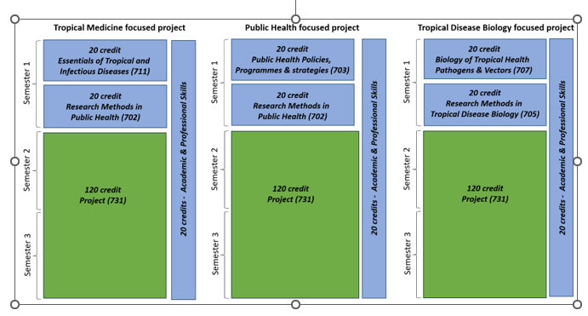
Each student has to choose one of the 20 credits Key Themes:
Depending on the 120-credit project topic, the student will choose between the following three options that best fits the project:
- 707: Biology of Tropical Health, Pathogens and Vectors of Disease
- 703: Public Health Policies, Programmes & Strategies: Concepts and Methods
- 711: Essentials of Tropical Medicine
Each student has to choose one of the 20 credits Key Research Methods:
Depending on the 120-credit project topic, the student will choose between these two options that best fits the project:
- 705: Research Methods in Tropical Disease Biology or
- 702: Research Methods in Public Health
All students take the 20 credits Academic and Professional Skills (701) (half a day a week, hybrid online and face-to-face offering during periods of fieldwork travel):
- Grant proposal design and management (proposal development, ethics, safeguarding, project management)
- Data Analysis Skills
- Academic and professional exercises (leadership development, critical evaluation, scientific writing and posters, literature searching, journal club)
All students take the 120 credit Research Project
- During 1st semester students will choose selections from a list of research questions offered by supervisors. Students will have the opportunity to discuss potential projects with supervisors over the first semester, and then select preferred options. Students will be made aware that they may not get their first-choice research subject.
- Students will be encouraged to contribute to research ideas and early plans prior to starting the programme where relevant
- Project can be desk, lab or field based. MRes Programme Directors will work with faculty representatives to ensure diverse project types are incorporated into the MRes.
- Face-to-face meetings with potential supervisors during the second half of semester 1 to discuss proposed projects, which should be shaped in more detail by discussions between the supervisor and the student
- Quality control of proposed projects by formative assessment of a written project proposal
- Project Assessment in the form or written report after completion of the relevant research, oral presentation and viva voce
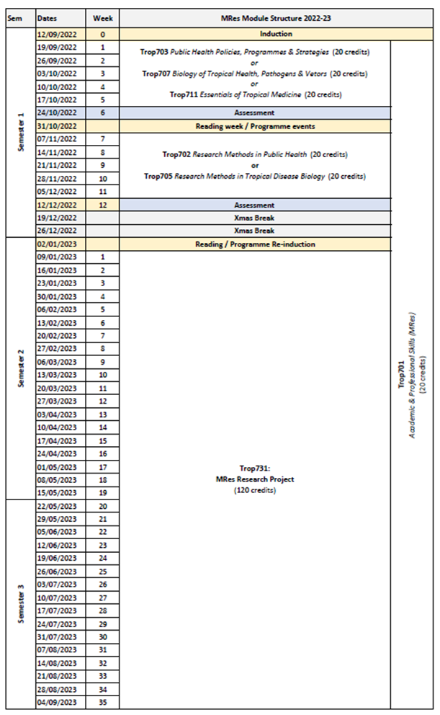

27c | Options
Semester(1)
Select one option from Block(1) and one option from Block(2) dependent on the 120-credit project topic
Block(1)
- 707: Biology of Tropical Health, Pathogens and Vectors of Disease
- 703: Public Health Policies, Programmes & Strategies: Concepts and Methods
- 711: Essentials of Tropical Medicine
Block(2)
- 705: Research Methods in Tropical Disease Biology
- 702: Research Methods in Public Health

Part E: Learning, Teaching and Assessment Strategies
28 | Learning, Teaching & Assessment Strategy
The L&T strategy is designed to help all students to express their full potential through a combination of formal teaching and directed student-centred learning. Lectures highlight key points and provide participants with a core knowledge base. Students are expected to enhance this core knowledge and become reflective, independent learners through guided enquiry-based self-study and use of on-line learning packages. Self-study is supported by informal staff contact, scheduled help sessions and on-line discussion. To develop cognitive and intellectual skills, the programme involves discussion of key issues, analysis and interpretation of resource material and practice in applying concepts and solving problems. Group work develops students’ abilities to work co-operatively, promotes creativity, provides opportunities to reflect critically and enables participants to take more responsibility for their own learning, as well as learn from each other. Practical skills are developed through opportunities to practise activities in the laboratory and in the field. Students can also take advantage of lectures given by the many distinguished researchers, practitioners and policymakers who regularly visit LSTM. The L&T methods adopted reflect the diversity of the LSTM student population and an ethical and culturally sensitive approach is emphasised throughout.
The assessment strategy is designed to encourage the students to develop and improve on a range of skills, including synthesising and evaluating information, academic writing, numerical and IT skills, team-working, presentation skills, and time management. Both formative and summative assessment approaches are used. General assessment procedures, assessment criteria and regulations with respect to late submission are communicated to the students in the LSTM Masters Student Handbook. Students are directed to the relevant module area in Brightspace for information relating to specific assignments.

29 | Assessment Schedule
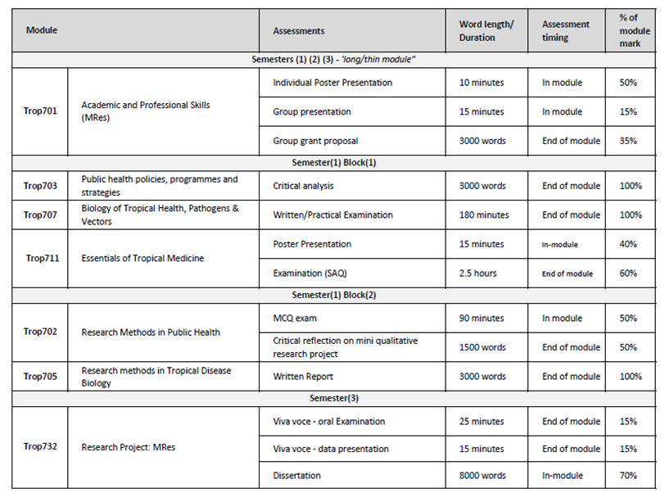
30 | Pass Mark
The pass mark for each module is 50%.
31 | Compensation and Resits
Compensation[
Where the overall average mark in all taught modules is 50% or above, a mark of 40-49% in one module of 20 credits will be deemed compensatable. Marks for modules passed by virtue of the compensation rule will be recorded as a pass mark of 50%.
Re-sits
Students who fail one or more modules at the first attempt will normally be offered one reassessment opportunity for each failed component. Reassessment will normally take place in the defined reassessment period, but where this is not possible, within twelve months of the failed assessment. A failed research project may be submitted on one further occasion only, within one year of the original date of submission. Marks achieved through reassessment will be capped at 50% for the purpose of calculating the overall average mark and determining classification for an award. The actual mark achieved through reassessment will be the mark recorded on the transcript. Students will not be permitted a reassessment opportunity for any module or assignment they have passed, with the aim of improving the mark, except in the case of extenuating circumstances. Further information relating to the re-sitting of examinations, including timing of re-sits, can be found in the LSTM Masters Student Handbook.
32 | Marking Descriptors
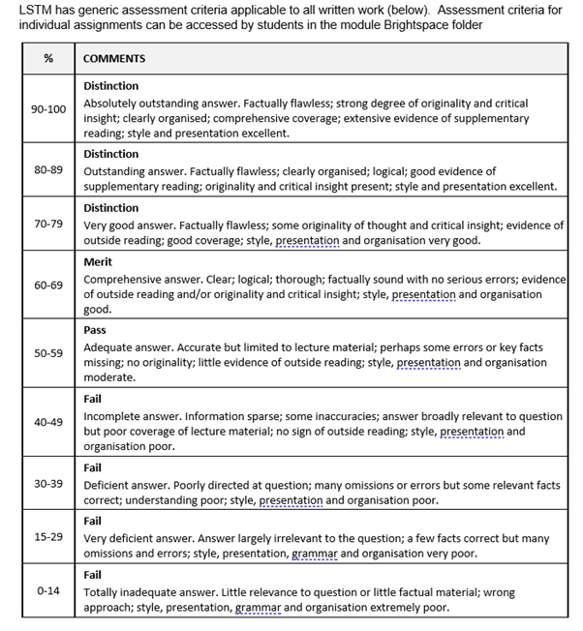

33 | Final Award and Alternative Qualifications
Final Award
Students who attend for a minimum period of 12 months of full-time study, and who achieve a minimum 180 credit points at FHEQ level 7, and successfully complete a research project worth120 credits will be eligible for the award of the MRes degree.
A mark of Merit or Distinction will be awarded according to the criteria below. A Merit or Distinction may be awarded if a student has failed and then passed on re-sit any credit that counts towards the final award during the relevant period of study at LSTM, however, marks are capped at 50% for the purposes of calculating the award.
Marks achieved in modules which are passed under the compensation rule may also be counted towards a Merit or Distinction. It should be noted that students who register on an MRes, but who exit with a lower award, will be eligible for a Merit or Distinction for the lower award, provided the student meets the criteria outlined below:
For an MRes Degree with Distinction a student must achieve:
- a Distinction grade for the dissertation and;
- an overall average of at least 70% in 60 credits of taught modules
For an MRes degree with Merit a student must achieve:
- a Merit grade for the dissertation and;
- an overall average mark of at least 60% in 60 credits of taught modules
For a Postgraduate Certificate with Distinction a student must achieve:
- an overall average mark of at least 70% in 60 credits of taught modules
For a Postgraduate Certificate with Merit a student must achieve:
- an overall average mark of at least 60% in 60 credits of taught modules
Criteria for the award of an alternative qualification
If a student fails to meet the criteria for the award of an MRes degree or is unable to complete the programme, he or she will be eligible for the award of one of the following as an exit qualification:
Postgraduate Certificate Tropical Health and Infectious Disease Research Design provided that the student has achieved a minimum of 60 taught credits.

Part F: Quality Assurance
34 | Examination Process
The MRes Board of Examiners consists of the Dean of Education (Chair), Academic Registrar (Secretary), the External Examiners from the relevant programmes and all members of academic staff who have made a major contribution to the teaching and assessment of the programmes.
The Terms of Reference are as follows:
- To monitor methods of assessment against set learning outcomes and programme requirements
- To ensure standards of assessment are maintained
- To assess students’ performance in accordance with regulations
- To reach overall decisions concerning awards
- To make recommendations to the Board of Studies on the conduct and standards of all assessment procedures
External Examiners are responsible for ensuring that awards made by LSTM are of a comparable standard with those of similar subjects and awards of other Higher Education Institutions in the United Kingdom, as stated in the Code of Practice on External Examining of Taught Programmes which is available at:
http://www.lstmed.ac.uk/study/quality-manual
Further information on the assessment policies and procedures can be found in the LSTM Masters Student Handbook, including:
- The penalties for the late submission of assessments
- The rules relating to plagiarism and collusion
- Ill-health and other special factors
Information on the purpose, method and schedule of assessment and the timescales for the submission of assessments can be found in the Programme Handbook (available on the LSTM student intranet) and on the Brightspace programme page.

35 | Student Representation and Feedback
LSTM is committed to receiving and responding to student feedback in order to develop learning and teaching within the institution and to improve the overall quality of the student experience. Students are encouraged to evaluate individual modules and the programme via an online survey tool. The survey results are reported at Board of Study (BoS) meetings, together with any additional feedback from the student representatives. Regular focus groups will be held and there are opportunities for informal feedback via tutors and module convenors.
Students will be formally represented within the LSTM committee structure:
- The Staff Student Liaison Committee (SSLC) meets 3 times a year and includes an elected representative from each programme, including any programme streams. The minutes of the SSLC are received by the Learning & Teaching Committee (L&TC). The membership of the SSLC, its terms of reference and the manner in which it conducts its business conform to the requirements of the Code of Practice on Student Engagement and Enhancing the Student Experience - http://www.lstmed.ac.uk/study/quality-manual
- Each Master’s programme has a Board of Studies (BoS), which oversees its planning, operation, management and development. Membership of the BOS consists of the Director of Studies for the Programme, the Academic Registrar, elected student representatives, Registry staff supporting the programme, Convenors of Modules and those making a significant contribution to the programme.
Students play an active role in the work of the BoS, with the exception of reserved and confidential business. The minutes of all Boards of Studies are received by the L&TC.
- The Quality Management Committee (QMC) oversees the academic standards and quality assurance and enhancement of all taught programmes, ensuring that LSTM’s quality assurance processes are fully informed by external expectations including the UK Quality Code for Higher Education. Two students from across all programmes serve as full members of the QMC. The QMC reports on academic quality assurance and enhancement issues to the L&T Committee. The Committee meets a minimum of four times per academic year and is responsible for:
- Approving, monitoring and reviewing programmes and modules
- Approving recommendations for the appointment of external examiners for LSTM programmes.
- Monitoring the progress of actions raised by External Examiners
- Developing, monitoring and reviewing the peer observation system

Part G: Diversity and Equality of Opportunity and Widening Participation
36 | Diversity and Equality Statement
The programme’s design, structure and content are consistent and compliant with the Diversity and Equality of Opportunity Policy. LSTM provides a multicultural, multidisciplinary learning environment in which all students benefit from the opportunity to share diverse experiences and outlooks, supported by staff who are themselves from a variety of national and cultural backgrounds and spend significant periods of time working overseas. LSTM recognises that some students need extra help and guidance in adjusting to a new country, culture or learning environment. Accordingly, we provide a comprehensive range of relevant non-academic student support services. The Personal Tutor System aims to provide students with advice and support in matters related to academic work and to enable the development of independent study habits suitable for higher education. Reasonable adjustments are made to assessment for disabled students in line with the Code of Practice on Student Support and Welfare.

Part H: Status of Professional, Statutory or Regulatory Body Accreditation
37 | Accreditation Status
Not applicable

Annex: Modifications
Annex of Modifications made to the Programme - Related List of Modification
Description of Modification (Please include details of any student consultation undertaken or confirm that students’ consent was obtained where this was required) | Major/Minor Modifications | Date Approved by QMC | Date Approved by Mgt Cttee | Cohort Affected

