Part A: Programme Summary Information

1 | Title of Programme | Humanitarian Studies
2 | Programme Code | MSc/HS
3 | Entry Award (s):
3a | Entry Award 1 | MSc – 180 Credits:7
3b | Entry Award 2 | PGDip – 120 Credits:7
3c | Entry Award 3 | PGCert – 60 Credits:7
4 | Exit Award (s):
4a | Exit Award 1 | MSc – 180 Credits:7
4b | Exit Award 2 | PGDip – 120 Credits:7
4c | Exit Award 3 | PGCert – 60 Credits:7

5a | Start Date | September 2023 |  | 5b | End Date | September 2024
6 | Frequency of Intake | Annually
7 | Mode of Study | FT
8a | Applicable Framework | LSTM LT REG 01
8b | Exemption Required
8c | Exemption Approved
8d | Details of Exemption
9 | Programme Director | Imri Schattner-Ornan
10 | Board of Studies | Humanitarian Masters Board of Studies
11 | Board of Examiners | MSc Board of Examiners
12 | External Examiner(s) | Pat Gibbons
13 | Professional or  Other Body | None
14 | Reference Points | Priorities of relevant national and international organisations in global health (Foreign, Commonwealth and Development Office, UK; United States Agency for International Development; World Health Organisation); QAA Master’s Degree Characteristics (2020); The Frameworks for Higher Education Qualifications of UK Degree-Awarding Bodies (2014)
15a | Home/EU Fee |  |  | 15b | Overseas Fee
16 | Additional Costs to the Student | The programme fee covers the cost of a desk-based project based in LSTM. Depending on your previous experience you may be permitted to undertake a lab-based project which will incur an additional fee, called a bench fee which will be approximately £1,500. You may also need to cover the costs of antibody testing and/or vaccinations needed for laboratory projects. Students are not required to pay this additional fee at registration but must have the necessary funds available when they start the programme. LSTM can also help students to arrange a field-based project overseas (typically 4 weeks) and students are encouraged to take this opportunity if your funds allow. Overseas projects will incur costs such as flights accommodation, hiring translators, travel in-country, visas, vaccinations, possibly fees for ethics applications so costs, depending on duration, nature of fieldwork and complexity of project can range from approximately £3,000-£5,000). The School will provide comprehensive insurance for off-site work and cover the cost of this.  While LSTM provides access to the main scientific software packages you will need for your dissertation, occasionally some students use specialist software for their dissertations beyond what LSTM provide and there could be a subscription fee, although often there is a period these can be used for free as a trial. There may additionally be course-relevant and social trips, which are optional for students to attend, and which may have costs attached.

Part B: Programme Aims and Outcomes
17 | Overview of the Programme
The programme reviews historical and current policies and practice in humanitarian assistance and explores novel approaches in responding to the challenges of today’s humanitarian problems. It is responding to the need for a professional, integrated, accountable and ethical approach to humanitarian interventions in which humanitarian workers are often called upon to operate in complex and demanding environments. LSTM’s humanitarian programme looks at the origin of humanitarianism, the current challenges the humanitarian system faces and the future directions it might take. The programme combines theoretical and practical elements and explores the connection between these.
Opportunities for in-depth study include modules addressing specific aspects of humanitarian interventions, such as Complex Emergencies, Climate Change and Health or Sexual and Reproductive Health. The programme offers participants an opportunity to develop and undertake a research project, overseas or in the UK, in their area of special interest. Alternatively, students may undertake a desk-based research study of a specialist aspect of humanitarian interventions; or they may undertake a placement with an appropriate non-governmental organisations, international organisations or national ministries.
From a student’s perspective, the programme follows a path from general introduction to the world of humanitarian action, to examining key settings and the management of relief operations, cumulating with the research project or placement, allowing students to incorporate both the practical and theoretical trends of the programme. At the same time, via the Scientific and Professional Skills, the programme offers opportunities to develop specific skills useful for the student. LSTM also runs a “student consultancy” project, where students, in groups, research and reflection, whilst gathering valuable professional skills, with an external partner such as a humanitarian organisation.
18 | Aims of the Programme
No. | Specific Aim |  | Entry Award
1 | Produce graduates who are committed, informed, pro-active and effective professionals, capable of taking substantial and leading professional roles in humanitarian interventions and activities. |  | All Awards
2 | To enable students to gain a deeper understanding of the history and political economy of war, disasters, climate change, and humanitarian action, with particular attention to the relief operations and the health and well-being of individuals and populations |  | All Awards
3 | Give participants an opportunity either to conduct an independent in-depth field-based or desk-based research study of a specialist aspect of humanitarian interventions or to undertake and document a placement / internship with an appropriate NGO / IO. |  | MSc Only
4 | Provide an interdisciplinary forum in which participants from a variety of professional backgrounds (e.g.health, political and social sciences, engineering, agriculture, development, international humanitarian law, human rights, administration and media) can explore differences and highlight shared approaches in humanitarian relief. |  | All Awards
5 | Facilitate high quality learning that is informed by critical analysis of current research related to the humanitarian sector |  | All Awards
19 Skills and Other Attributes
No. |  |  | Skill/Attribute |  | Module(s) | Mode of Assessing
1 |  |  | To communicate ideas, knowledge, and strategies confidently and effectively, both orally and in writing |  | All modules | Written assessments and oral presentations
2 |  |  | To take responsibility for self-managed learning |  | All modules | Indirect contribution to all assessments
3 |  |  | To work effectively both independently and in collaboration with others |  | All modules | Indirect contribution to all assessments
4 |  |  | To apply skills in effective research project and time management to set goals, prioritise activities and meet deadlines |  | All modules | Assessed indirectly in all modules through timely submission of assessments
5 |  |  | To apply numerical and IT skills with confidence and accuracy |  | Trop 702, 732, 700 | Formative examination (702, 700); dissertation data analysis (732).
20 |  | Subject Based Learning Outcomes
A |  | Knowledge and Understanding. Upon successful completion of the programme, a student should have developed and be able to demonstrate:
No. |  | Learning Outcome |  |  | Module(s) | Mode of Assessing | Entry Award
A1 |  | A systematic understanding and critical awareness of current issues and priorities in the field of humanitarian studies |  |  | Trop 704, 712, 718 726 | Essays, assignments, presentations | All Awards
A2 |  | Ability to critically analyse the impact of humanitarian emergencies on health and well-being |  |  | Trop 704, 712, 718, 726 | Essays, assignments, presentations | All Awards
A3 |  | Knowledge of a range of relevant research methods and understanding of how the methods can be applied to address particular research questions |  |  | Trop 702, 732, 700 | Exam (MCQ), research proposal, essay, dissertation | All Awards
A4 |  | Ability to apply knowledge and understanding of quantitative and/or qualitative methods in the design of a research study and to analyse and interpret critically data |  |  | Trop 702, 732, 700 | Exam (MCQ), research proposal, essay, dissertation | All Awards
A5 |  | Expertise in critically appraising the evidence base for current operational guidelines |  |  | Trop 704, 712, 718, 726 | Essays, assignments, presentations, dissertation | All Awards
B |  | Cognitive Skills. Upon successful completion of the programme, a student should be able to:
No. |  | Learning Outcome |  |  | Module(s) | Mode of Assessing | Entry Award
B1 |  | Apply the principles and values of ethical practice with regard to the design and practice of research studies, consent and confidentiality in the collection and presentation of data, and publication |  |  | Trop 732, 700 | Dissertation; Written Report; Presentation, Research proposal | All Awards
B2 |  | Analyse, synthesise and evaluate information from a variety of sources in a critical manner |  |  | Trop 704, 712, 718, 726, 732 | Essays, assignments, presentations, dissertation | All Awards
B3 |  | Apply subject knowledge and understanding in a variety of contexts to analyse and reach evidence-based conclusions on complex situations, problems and opportunities |  |  | Trop 704, 712, 718, 726, 732 | Essays, assignments, presentations, dissertation | All Awards
B4 |  | Demonstrate creativity, innovation and originality in the application of knowledge |  |  | Trop 704, 712, 718, 726, 732 | Essays, assignments, presentations, dissertation | All Awards
C |  | Practical/Professional Skills. Upon successful completion of the programme, a student should be able to:
No. |  | Learning Outcome |  | Module(s) |  | Mode of Assessing |  | Entry Award
C1 |  | Comprehend and integrate the working environment of relief operations by knowledge of working practices, best-practices and priorities. |  | Trop 700, 718 |  | Essay, presentations, written report, research proposal |  | All Awards
C2 |  | Formulate a research question, (or equivalent, e.g. project objective leading to recommendations), devise an appropriate research strategy and take a systematic approach to project planning and management |  | Trop 700, 702, 732 |  | Written report, presentation, research proposal, Exam (MCQ), essay, dissertation, placement / consultancy project report |  | All Awards
C3 |  | Effectively manage, analyse and report data (collected in the field, in a desk-based study or literature review) |  | Trop 700, 702, 732 |  | Written report, presentation, research proposal, Exam (MQC), essay, dissertation |  | All Awards
C4 |  | Undertake research investigations in a responsible, safe and ethical manner and accurately record the data collected |  | Trop 732, 700 |  | Written report, presentation, research proposal, Dissertation |  | All Awards
21 | Career Opportunities
The MSc Humanitarian Studies leads to a variety of careers and professional paths, within and beyond the humanitarian world. The expert skills, specialist knowledge and in-depth understanding gained in the programme prepare graduates to work at a senior level for global organisations working to help prevent and respond to humanitarian crises.
LSTM alumni students have gone on to management positions in international NGOs or UN agencies, managing activities in disaster and conflict areas. Others are working in the UK or beyond, with communities such as migrants, refugees, and asylum seekers. Our alumni are found in advocacy, fund-raising, media relations or technical expert roles. Many alumni have gone to work in management and leadership roles in the private sector, as well as government agencies such as the NHS, or as healthcare providers. Finally, some have continued their studies do to research on humanitarian and health related topics.

Part C: Entrance Requirements

22 | Academic Requirements | Open to graduates with at least a Second-Class Honours Bachelor's degree or overseas equivalent, although each application is judged on its own merits and exceptions to this entry requirement may be made. We will consider graduates from all disciplines as the programme is interdisciplinary. Evidence of engagement with the humanitarian or voluntary sector is desirable, but not essential. Medical students who have completed at least three years of study and wish to intercalate are also accepted onto the programme.
23 | English Language Requirements | The programme is taught in English. Applicants whose first language is not English must normally provide evidence of an IELTS (International English Language Testing System) score of at least 6.5 with a minimum of 5.5 in all learning components, or a TOEFL (Test of English as a Foreign Language) score of at least 88 for the Internet-based Test (iBT), with minimum scores of 21 for Listening and Writing, 22 for Reading and 23 for Speaking. Tests should be within their validity period of 2 years. Other English Language Tests and country specific English Language qualifications are also accepted - a full list with details of levels required can be found on the LSTM website (http://www.lstmed.ac.uk/study/how-to-apply/english-language-requirements). Applicants who have recently completed a degree level qualification taught in a majority English speaking country (as defined by UK Visas and Immigration (UKVI) may also be accepted at the discretion of the Director of Studies.
24 | Recognition of Prior Learning | All programmes of study will permit entry with credit attributed to previous certificated study up to a total of one third of the credits required to be awarded a MSc Degree, Postgraduate Diploma, Postgraduate Certificate or Postgraduate Award.
25 | Work Experience | Non-graduates with considerable satisfactory work experience and evidence of appropriate in-service training will also be considered. Field experience is desirable but not essential.
26 | Other Requirements | None

Part D: Programme Structure

27a | Overview
LSTM programmes are taught within a dynamic environment by staff working at the cutting-edge of research in humanitarianism, tropical medicine and global health. They are designed to enable the professional development of the student, to be relevant to students from both the UK and overseas and to promote approaches to study that will enable students to continue their learning into the future.
The programme comprises an introductory induction week, taught modules totalling 120 credits and a 60 credit dissertation. A 20-credit module (10 ECTS credits) represents 200 hours of student learning activity including assessment and self-directed study. Many students carry out a fieldwork-based dissertation project overseas or in the UK, but students can opt to conduct a laboratory project if they are suitably qualified, or literature-based project that does not involve fieldwork. All types of projects have the key aims of developing the students’ skills in formulating a research question, designing and implementing a research project and critically interpreting and presenting the findings. The timing of modules across the academic year recognises the financial and time constraints faced by LSTM students, many of whom are from overseas. To allow students to access LSTM programmes in an economical and time-efficient manner, there are only 2 weeks holiday scheduled over Christmas. The remaining weeks of holiday are deferred to the end of the academic year.
The modules available to students following the programme are shown in Section 27b. Required modules are necessary to achieve the programme learning outcomes and must be taken by all students following the programme. Currently, only the final block of the 2nd term provides optional modules. Depending on their background or interests, students may opt to replace a recommended optional module with one offered as part of another LSTM MSc programme, subject to the agreement of the Director of Studies and any restrictions on class size.

27b | Timetable
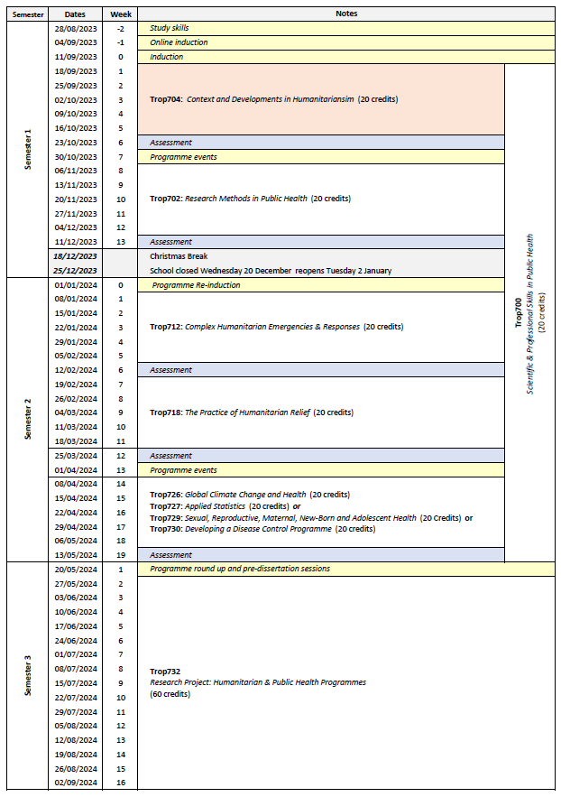

27c | Options
Trop726: Global Climate Change & Health is optional.
Following discussion with the Programme Director, students may be able to replace Trop726 with one of the modules shown below taken from other LSTM MSc programmes:
- Trop727 Applied Statistics
- Trop729 Sexual, Reproductive, Maternal, Newborn & Adolescent Health
- Trop730 Developing a Disease Control Programme

Part E: Learning, Teaching and Assessment Strategies
28 | Learning, Teaching & Assessment Strategy
The L&T strategy is designed to help all students to express their full potential through a combination of formal teaching and directed student-centred learning. Lectures highlight key points and provide participants with a core knowledge base. Students are expected to enhance this core knowledge and become reflective independent learners through guided enquiry-based self -study and use of on-line learning packages. Self-study is supported by informal staff contact, scheduled help sessions and on-line discussion. To develop cognitive and intellectual skills, the programme involves discussion of key issues, analysis and interpretation of resource material and practice in applying concepts and solving problems. Group work develops students’ abilities to work co-operatively, promotes creativity, provides opportunities to reflect critically and enables participants to take more responsibility for their own learning, as well as learn from each other. Practical skills are developed through opportunities to practise activities in the laboratory and in the field. Students can also take advantage of lectures given by the many distinguished researchers and policymakers who regularly visit LSTM. The L&T methods adopted reflect the diversity of the LSTM student population and an ethical and culturally sensitive approach is emphasised throughout.
The assessment strategy is designed to encourage the student to develop and improve on a range of skills, including synthesising and evaluating information, academic writing, numerical and IT skills, team-working, presentation skills, and time management. Both formative and summative assessment approaches are used. General assessment procedures, assessment criteria and regulations with respect to late submission are communicated to the students in the LSTM Masters Student Handbook. Students are directed to the relevant module area in Brightspace for information relating to specific assignments.

29 | Assessment Schedule
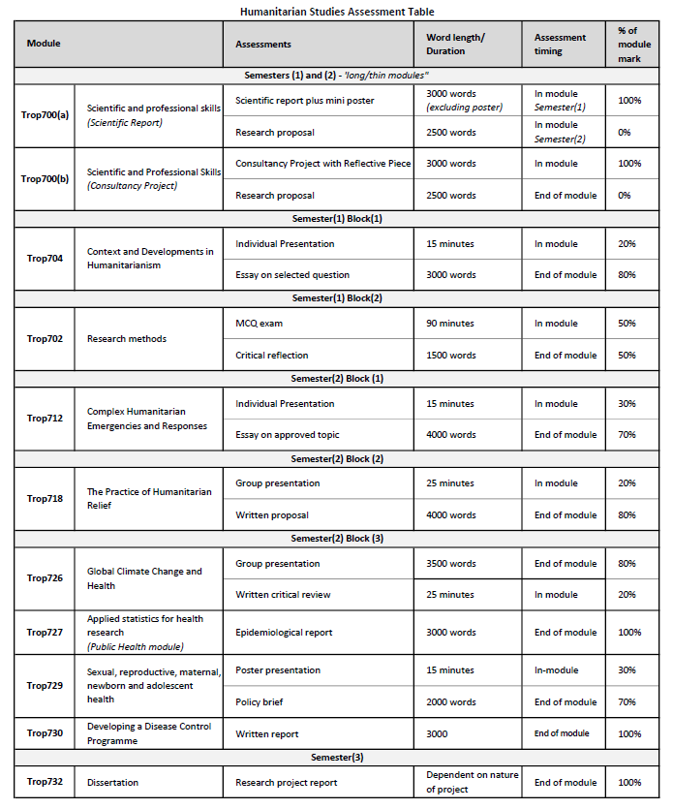

30 | Pass Mark
The pass mark for each module is 50%.
31 | Compensation and Resits
Compensation
Where the overall average mark in all taught modules is 50% or above, a mark of 40-49% in one module of 20 credits will be deemed compensable. The compensation rule will not apply to the Postgraduate Award or to stand-alone modules. Marks for modules passed by virtue of the compensation rule will be recorded as a pass mark of 50%.
Re-sits
Students who fail one or more modules at the first attempt will normally be offered one reassessment opportunity for each failed component. Reassessment will normally take place in the defined reassessment period, but where this is not possible, within twelve months of the failed assessment. A failed research project may be submitted on one further occasion only, within one year of the original date of submission. Marks achieved through reassessment will be capped at 50% for the purpose of calculating the overall average mark and determining classification for an award. The actual mark achieved through reassessment will be the mark recorded on the transcript. Students will not be permitted a reassessment opportunity for any module or assignment they have passed, with the aim of improving the mark, except in the case of extenuating circumstances. Group assignments marked together will re-sit as a group unless circumstances requiring individual re-sits exist. Further information relating to the re-sitting of examinations, including timing of re-sits, can be found in the LSTM Masters Student Handbook.
32 | Marking Descriptors
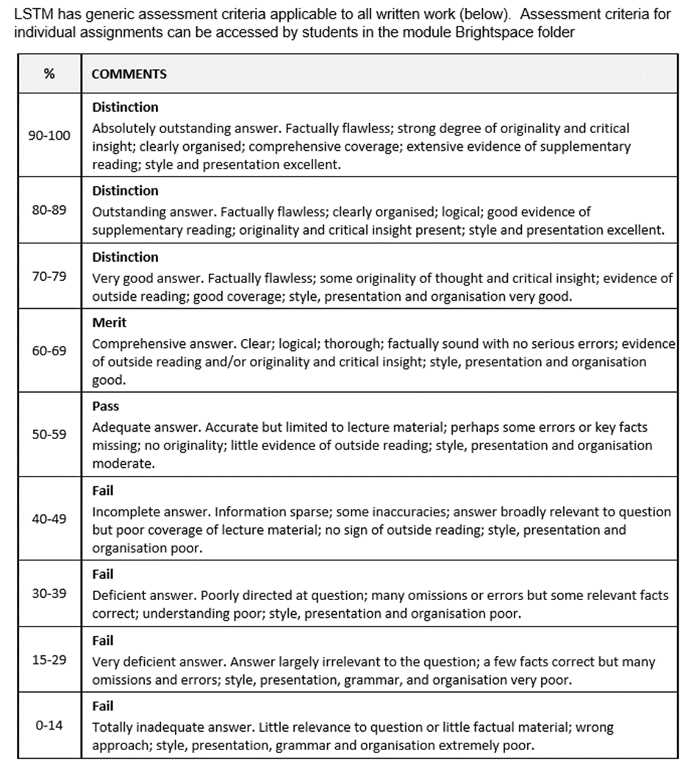

33 | Final Award and Alternative Qualifications
Final Award
Students who attend for a minimum period of 12 months of full-time study, and who achieve a minimum 180 credit points at FHEQ level 7, and successfully complete a dissertation/research project worth 60 credits will be eligible for the award of a Master’s degree. In order to be awarded the MSc Humanitarian Studies, the credits achieved must include Trop704: Context and Developments in Humanitarianism and Trop712 Complex Humanitarian Emergencies and Responses.
Students who attend for a minimum period of 30 weeks of full-time study, and who achieve a minimum of 120 credit points at FHEQ level 7, will be eligible for the award of a Postgraduate Diploma. A Postgraduate Diploma shall be comprised either of all taught modules if an entry award or may include the 60-credit research project module if an exit award. To be awarded the Postgraduate Diploma Humanitarian Studies, candidates must achieve 120 credits from the taught component of the MSc programme (i.e., excluding Trop732), to include Trop704: Context and Developments in Humanitarianism and Trop712 Complex Humanitarian Emergencies and Responses.
Students who attend for a minimum period of 15 weeks full-time study, and who achieve a minimum of 60 credit points at FHEQ level 7, will be eligible for the award of a Postgraduate Certificate. To be awarded the Postgraduate Certificate Humanitarian Studies, the credits achieved must include a total of 60 credits to include: Trop704: Context and Developments in Humanitarianism and Trop712 Complex Humanitarian Emergencies and Responses., and either Trop718 The Practice of Humanitarian Relief or Trop726 Global Climate Change and Health.
For a Master’s degree with Distinction a student must achieve:
- An overall average of at least 70% across all modules, and
- A Distinction grade for the dissertation; or
- a Distinction grade for the average of the taught modules.
For a Postgraduate Diploma with Distinction a student must achieve:
- An overall average mark of at least 70% in 120 credits of modules, which can be made up of the taught modules alone or taught modules and the dissertation (120 Credits).
For a Postgraduate Certificate with Distinction a student must achieve:
- an overall average mark of at least 70% in 60 credits of taught modules
For a Master’s degree with Merit a student must achieve:
- An overall average of at least 60% across all modules, and
- A Merit grade for the dissertation; or
- a Merit grade for the average of the taught modules.
For a Postgraduate Diploma with Merit a student must achieve:
- An overall average mark of at least 60% in 120 credits of modules, which can be made up of the taught modules alone or taught modules and the dissertation (120 Credits).
For a Postgraduate Certificate with Merit a student must achieve:
- an overall average mark of at least 60% in 60 credits of taught modules
Average marks falling up to 2% below any grade boundary are deemed to be borderline cases. In these cases, the award is determined by consideration of the profile of marks across all taught modules. To be awarded the higher grade, at least 50% of the taught credits must be at the higher grade.
Students who take modules on a stand-alone basis will become eligible for an award with Distinction or Merit where they:
- Subsequently register for a programme of study which leads to an award and successfully complete the required credit through the study of appropriate modules as defined in the programme specification or accumulate sufficient credit for an unnamed award in accordance with an approved programme of study.
Where a student has successfully completed modules which exceed the required credit for the award the calculation of the overall average mark and determination of classification will be based on the modules with the higher marks.
Criteria for the award of an alternative qualification
If a student fails to meet the criteria for the award of a Master’s degree or a Postgraduate Diploma, or is unable to complete the programme he or she registered for, they may be eligible for the award of one of the following as an exit qualification:
- Postgraduate Diploma Humanitarian Studies will be awarded to students who have previously registered for the Master’s degree provided that the student has achieved a minimum of 120 credits. The 120 credits may include dissertation credits to the value of 60 credits. To qualify for a Postgraduate Diploma Humanitarian Studies, the credits achieved must include Trop704: Context and Developments in Humanitarianism and Trop712 Complex Humanitarian Emergencies and Responses. Students who exit without having achieved the core modules may be eligible for an unnamed Postgraduate Diploma.
- Postgraduate Certificate Humanitarian Studies will be awarded to students who have previously registered for the Master’s Degree or the Postgraduate Diploma of 60 credits. The credit may not include any dissertation credits. To qualify for a Postgraduate Certificate Humanitarian Studies, the credits achieved must include Trop704: Context and Developments in Humanitarianism and Trop712 Complex Humanitarian Emergencies and Responses. Students who exit without having achieved the core modules may be eligible for an unnamed Postgraduate Certificate.

Part F: Quality Assurance
34 | Examination Process
The Masters Board of Examiners consists of the LSTM Dean of Education (Chair), Academic Registrar (Secretary), the External Examiners from all LSTM MSc programmes and all members of academic staff who have made a major contribution to the teaching and assessment of the programmes.
The Terms of Reference are as follows:
- To monitor methods of assessment against set learning outcomes and programme requirements
- To ensure standards of assessment are maintained
- To assess students’ performance in accordance with regulations
- To reach overall decisions concerning awards
- To make recommendations to the Board of Studies on the conduct and standards of all assessment procedures
External Examiners are responsible for ensuring that awards made by LSTM are of a comparable standard with those of similar subjects and awards of other Higher Education Institutions in the United Kingdom, as stated in the Code of Practice on External Examining which is available at: http://www.lstmed.ac.uk/study/quality-manual
Further information on the assessment policies and procedures can be found in the LSTM Masters Student Handbook, including:
- The penalties for the late submission of assessments
- The rules relating to plagiarism and collusion
- Ill-health and other special factors
Information on the purpose, method and schedule of assessment and the timescales for the submission of assessments can be found in the Programme Handbook (available on the LSTM student intranet) and on the Brightspace programme page.

35 | Student Representation and Feedback
Box 35 Student Representation and Feedback
LSTM is committed to receiving and responding to student feedback in order to develop learning and teaching within the institution and to improve the overall quality of the student experience. Students are encouraged to evaluate individual modules and the programme via an online survey tool. The survey results are reported at Board of Study (BoS) meetings, together with any additional feedback from the student representatives. Regular focus groups will be held and there are opportunities for informal feedback via tutors and module convenors.
Students will be formally represented within the LSTM committee structure:
- The Staff Student Liaison Committee (SSLC) meets 3 times a year and includes an elected representative from each programme, including any programme streams. The minutes of the SSLC are received by the Learning & Teaching Committee (L&TC). The membership of the SSLC, its terms of reference and the manner in which it conducts its business conform to the requirements of the Code of Practice on Student Engagement and Enhancing the Student Experience - http://www.lstmed.ac.uk/study/quality-manual
- Each Master’s programme has a Board of Studies (BoS), which oversees its planning, operation, management and development. Membership of the BOS consists of the Director of Studies for the Programme, the Academic Registrar, elected student representatives, Registry staff supporting the programme, Convenors of Modules and those making a significant contribution to the programme.
Students play an active role in the work of the BoS, with the exception of reserved and confidential business. The minutes of all Boards of Studies are received by the L&TC.
- The Quality Management Committee (QMC) oversees the academic standards and quality assurance and enhancement of all taught programmes, ensuring that LSTM’s quality assurance processes are fully informed by external expectations including the UK Quality Code for Higher Education. Two students from across all programmes serve as full members of the QMC. The QMC reports on academic quality assurance and enhancement issues to the L&T Committee. The Committee meets a minimum of four times per academic year and is responsible for:
- Approving, monitoring and reviewing programmes and modules
- Approving recommendations for the appointment of external examiners for LSTM programmes.
- Monitoring the progress of actions raised by External Examiners
- Developing, monitoring and reviewing the peer observation system

Part G: Diversity and Equality of Opportunity and Widening Participation
36 | Diversity and Equality Statement
The programme’s design, structure and content are consistent and compliant with the University’s Diversity and Equality of Opportunity Policy. LSTM provides a multicultural, multidisciplinary learning environment in which all students benefit from the opportunity to share diverse experiences and outlooks, supported by staff who are themselves from a variety of national and cultural backgrounds and spend significant periods of time working overseas. LSTM recognises that some students need extra help and guidance in adjusting to a new country, culture or learning environment. Accordingly, we provide a comprehensive range of relevant non-academic student support services. The Personal Tutor System aims to provide students with advice and support in matters related to academic work and to enable the development of independent study habits suitable for higher education. Reasonable adjustments are made to assessment for disabled students in line with University of Liverpool regulations (Code of Practice on Assessment 2012-13: Appendix K).

Part H: Status of Professional, Statutory or Regulatory Body Accreditation
37 | Accreditation Status
Not applicable

Annex: Modifications
Annex of Modifications made to the Programme - Related List of Modification
Description of Modification (Please include details of any student consultation undertaken or confirm that students’ consent was obtained where this was required) | Major/Minor Modifications | Date Approved by QMC | Date Approved by Mgt Cttee | Cohort Affected

