Part A: Programme Summary Information

1 | Title of Programme | Tropical Disease Biology
2 | Programme Code | MSc/TDB
3 | Entry Award (s):
3a | Entry Award 1 | MSc – 180 Credits:7
3b | Entry Award 2 | PGDip – 120 Credits:7
3c | Entry Award 3 | PGCert – 60 Credits:7
4 | Exit Award (s):
4a | Exit Award 1 | MSc – 180 Credits:7
4b | Exit Award 2 | PGDip – 120 Credits:7
4c | Exit Award 3 | PGCert – 60 Credits:7

5a | Start Date | September 2023 |  | 5b | End Date | September 2024
6 | Frequency of Intake | Annually
7 | Mode of Study | FT
8a | Applicable Framework | LSTM LT REG 01
8b | Exemption Required
8c | Exemption Approved
8d | Details of Exemption
9 | Programme Director | James LaCourse
10 | Board of Studies | Tropical Disease Biology Masters Board of Studies
11 | Board of Examiners | MSc Board of Examiners
12 | External Examiner(s) | Dr. Matthew Rogers (LSHTM)
13 | Professional or  Other Body | None
14 | Reference Points | Priorities of relevant national and international organisations in global health (Department for International Development, UK; United States Agency for International Development; World Health Organisation); QAA Master’s Degree Characteristics Statement (2020); The Frameworks for Higher Education Qualifications of UK Degree-Awarding Bodies (2014)
15a | Home/EU Fee |  |  | 15b | Overseas Fee
16 | Additional Costs to the Student | The programme fee covers the cost of the induction field course. Students may wish to bring a small amount of spending money for the evening social events. The programme fee also covers the cost of a laboratory-based or desk-based project in LSTM. Some projects also involve a short period of data collection overseas (normally 2-4 weeks). Overseas or field projects will incur costs such as transport, accommodation, hiring translators, travel in-country, visas, vaccinations, possibly fees for ethics applications. Costs, depending on duration, nature of fieldwork and complexity of project can range from approximately £1,500-£5,000. Students are not required to pay these additional costs at registration but must have the necessary funds available in March-May when booking travel, accommodation etc. The School will provide comprehensive insurance for off-site work and cover the cost of this. There may additionally be course-relevant and social trips, which are optional for students to attend, and which may have costs attached.

Part B: Programme Aims and Outcomes
17 | Overview of the Programme
The MSc programme ‘Tropical Disease Biology’ provides advanced and research-informed contemporary learning in parasitology, microbiology, host-pathogen interactions, and the study of disease vectors and the pathogens they transmit in tropical and/or resource-limited regions of the world. Delivered by an internationally diverse team of research-active experts in their disciplines, the broad scope of the programme ranges across the biology, biochemistry, immunology, ecology, and population biology of the organisms of importance to public health in predominantly tropical regions of limited resource, and their associated epidemiology.
The programme will give students the opportunity to develop employer-relevant transferable skills, producing independent and collaborative team workers, critical thinkers, adaptable problem-solvers, and as confident communicators in a range of environments. Experience in essential laboratory, field, and computing-based research techniques, as well as significant theoretical and applied practical knowledge in all important and topical areas of the field is further provided within core taught elements. Participants further demonstrate and apply their comprehensive understanding and critical awareness through completion of a research-based dissertation either overseas or in Liverpool, with opportunities to engage with professional and industrial bodies in global health as part of this process.
18 | Aims of the Programme
No. | Specific Aim |  | Entry Award
1 | To produce students with a critically developed, comprehensive knowledge and understanding of the current issues and priorities with regard to the biology of host-pathogen interactions, and control of pathogens, vectors of disease, and organisms of importance to public health in tropical and resource-limited regions of the world. |  | All Awards
2 | To enable students to identify, conceptualise and frame research questions, and critically analyse problems and challenges with relevance to the biology and control of the pathogens, vectors of disease, and organisms of importance to public health in tropical and resource-limited settings and contexts. |  | All Awards
3 | To provide applied experience, and equip students with the abilities to design strategies, and apply a range of specialised technical and analytical skills, to respond to biologically related research questions, problems, and challenges in regard to the pathogens, vectors of disease, and organisms of importance to public health in tropical and resource-limited settings and contexts. |  | All Awards
4 | To equip students with transferable abilities and skills in critical and reflective thinking, effective, independent, and collaborative team working, adaptable problem-solving, ethical project planning and management, and in confident communication within a range of environments/contexts. |  | All Awards
19 Skills and Other Attributes
No. |  |  | Skill/Attribute |  | Module(s) | Mode of Assessing
1 |  |  | To communicate complex principles, knowledge, and strategies confidently and effectively, via a range of media including oral, visual and written, to a variety of relevant audiences. |  | All modules | Written assessments and oral presentations
2 |  |  | To apply statistical and scientific computing skills with confidence and accuracy. |  | TROP 714, 728, 705, 733, 700, 715, 727 | Formative and summative calculation exercises (727); examination (705); laboratory reports (728, 723,); dissertation data analysis (733); poster/slides presentation with data analyses included (714, 715)
3 |  |  | To work effectively both independently and in collaboration with others. |  | All modules. | Indirect contribution to all assessments
4 |  |  | To take responsibility for self-managed learning. |  | All modules | Indirect contribution to all assessments
5 |  |  | To apply skills in effective project and time management to set goals, prioritise activities and meet deadlines. |  | All modules | Assessed indirectly in all modules through timely submission of assessments
20 |  | Subject Based Learning Outcomes
A |  | Knowledge and Understanding. Upon successful completion of the programme, a student should have developed and be able to demonstrate:
No. |  | Learning Outcome |  | Module(s) |  | Mode of Assessing | Entry Award
A1 |  | Define and critically appraise current issues and priorities in the fields of biology, host-pathogen interaction, molecular and cellular biology, epidemiology, and control, of pathogens, vectors of disease, and organisms of importance to public health with particular emphasis on tropical and resource-limited regions of the world. |  | 714, 728, 722, 723, 707, 715, 700 |  | Practical & written exams, essays, presentation | All Awards
A2 |  | Review, identify and comprehensively describe appropriate research methods to answer research questions with relevance to the biology and control of the pathogens, vectors of disease, and organisms of importance to public health in tropical and resource-limited settings and contexts. |  | 705, 733, 727, 715, 700, 723 |  | Practical Reports, written exams, research notebook, presentation, dissertation | All Awards
A3 |  | Critically appraise and evaluate current methods, findings, and research developments in preventing human disease, that may lead to the development of novel control strategies with particular emphasis on tropical and resource-limited regions of the world. |  | 714, 728, 722,723, 705, 707, 733, 700 |  | Practical & written exams, essays, practical report, presentation, dissertation | All Awards
A4 |  | Critically analyse and interpret statistical data in the design of a research study. |  | 714, 723, 705, 733, 727 715, 700 |  | Practical Reports, written exams, dissertation, presentation | All Awards
B |  | Cognitive Skills. Upon successful completion of the programme, a student should be able to:
No. |  | Learning Outcome |  | Module(s) |  | Mode of Assessing | Entry Award
B1 |  | Critically analyse, synthesise and evaluate information from a variety of sources. |  | 714, 728, 722, 705, 707, 733, 715, 700 |  | Practical & written exams, essays, practical report, presentation, research notebook, dissertation | All Awards
B2 |  | Apply subject knowledge and understanding in a variety of contexts to analyse and reach evidence-based conclusions on complex situations, problems and opportunities. |  | 714, 728, 722, 705, 707, 733, 700 |  | Practical & written exams, essays, presentation, practical reports, dissertation | All Awards
B3 |  | Review the principles and values of ethical practice with regard to the design and practice of research studies, consent and confidentiality in the collection and presentation of data, and publication. |  | 705, 733, 700 |  | Research proposal (705) and dissertation (733) | All Awards
B4 |  | Demonstrate creativity, innovation and originality in the application of knowledge. |  | 714, 728, 722, 723, 733, 705, 707, 715, 727, 700 |  | Practical reports, research proposal, written & practical exams, presentations, essays, research notebook, dissertation | All Awards
C |  | Practical/Professional Skills. Upon successful completion of the programme, a student should be able to:
No. |  | Learning Outcome |  | Module(s) |  | Mode of Assessing | Entry Award
C1 |  | Formulate a research question, devise an appropriate research strategy and take a systematic approach to project planning and management. |  | 714, 728, 722,723, 705, 733, 715, 727, 700 |  | Practical reports, presentations, research proposal, dissertation. | All Awards
C2 |  | Undertake research investigations in a responsible, safe and ethical manner, select with critical awareness and deploy accurately with precision, techniques and methods, and record data collected. |  | 733 |  | Dissertation | MSc Only
C3 |  | Effectively manage, analyse, and critically interpret data collected in the laboratory, field setting and in silico. |  | 714, 728, 722, 723, 705, 707, 733, 715, 727, 700 |  | Field course, practical reports, research proposal, dissertation, research notebook, presentation | All Awards
C4 |  | Critically appraise and select effective means of reporting and communicating research questions, strategies and findings within differing contexts and environments |  | 714, 728, 722, 723, 705, 733, 715, 727, 700 |  | Practical reports, research proposal, dissertation, research notebook, presentation | All Awards
21 | Career Opportunities
Many alumni of LSTM hold prominent positions in health ministries, universities, hospitals, and international organisations throughout the world. Graduates are competitively placed to begin PhD programmes, seek employment within research programmes, work overseas in resource-limited areas with a wide variety of employers including NGOs, military and public health-related employers, enter teacher training, industry, or return to previous employers with enhanced knowledge and widely transferable skills with which to advance their existing careers. Graduates of the MSc Tropical Disease Biology will have undergone excellent preparation for a career in laboratory and field research, or training, in the biological sciences, and are particularly well placed for careers in topics related to organisms of importance to public health, including a variety of pathogens and vector-borne diseases globally, and particularly within tropical or resource-limited regions of the world.

Part C: Entrance Requirements

22 | Academic Requirements | Open to graduates with an Honours degree (2.ii or equivalent) in the biological sciences or a medical/veterinary degree. Overseas candidates with other qualifications may be accepted, particularly if they have the relevant experience through working in an appropriate field for a number of years. Medical or Veterinary students who have completed at least three years of study and wish to intercalate are also accepted onto the programme.
23 | English Language Requirements | The programme is taught in English. Applicants whose first language is not English must normally provide evidence of an IELTS (International English Language Testing System) score of at least 6.5 with a minimum of 5.5 in all learning components, or a TOEFL (Test of English as a Foreign Language) score of at least 88 for the Internet-based Test (iBT), with minimum scores of 21 for Listening and Writing, 22 for Reading and 23 for Speaking. Tests should be within their validity period of 2 years. Other English Language Tests and country specific English Language qualifications are also accepted - a full list with details of levels required can be found on the LSTM website (http://www.lstmed.ac.uk/study/how-to-apply/english-language-requirements). Applicants who have recently completed a degree level qualification taught in a majority English speaking country (as defined by UK Visas and Immigration (UKVI) may also be accepted at the discretion of the Director of Studies.
24 | Recognition of Prior Learning | All programmes of study will permit entry with credit attributed to previous certificated study up to a total of one third of the credits required to be awarded a MSc Degree, Postgraduate Diploma, Postgraduate Certificate or Postgraduate Award.
25 | Work Experience | Non-graduates with considerable satisfactory work experience and evidence of appropriate in-service training will also be considered.
26 | Other Requirements | None

Part D: Programme Structure

27a | Overview
The programme is offered within a dynamic research-led environment and its content is informed by the cutting-edge research activities of the academic staff. It is designed to enable the professional development of the student, to be relevant to students from both the UK and overseas and to promote approaches to study that will enable graduates to continue their learning into the future.
The programme comprises an introductory induction period including a residential field course element at the start of the programme, taught modules totalling 120 credits and a 60 credit dissertation. A 20 credit module (5 ECTS credits) represents 200 hours of student learning activity including assessment and self-directed study. Many students carry out a laboratory or data/literature-based dissertation project in LSTM but students can opt to conduct a fieldwork-based project overseas. All types of project have the key aims of developing the students’ skills in formulating a research question, designing and implementing a research project and critically interpreting and presenting the findings.
The modules available to students following the programme are shown in Section 27b. Required modules are necessary to achieve the programme learning outcomes and must be taken by all students following the programme. The optional modules listed have been identified as most suitable for contributing to the attainment of the programme learning outcomes. However, depending on their background or interests, students may opt to replace a recommended optional module with one offered as part of another LSTM MSc programme (Section 27c), subject to the agreement of the Director of Studies and any restrictions on class size.

27b | Timetable
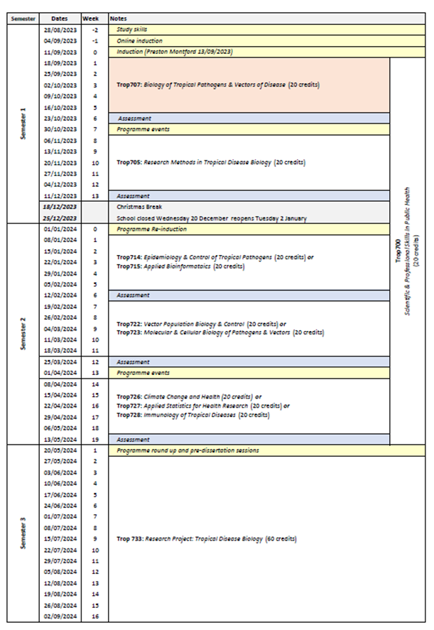

27c | Options
Core Modules. Students must take the following core modules (60 credits in total)
Semester(1) Block (1)
- Trop707 Biology of Tropical Health, Pathogens & Vectors of Disease
Semester(1) Block(2)
- Trop705 Research Methods in Tropical Disease Biology Block(1)
Semesters(1) & (2)
- Trop700(a) Scientific & Professional Skills (runs over semester 1 and 2)
Optional modules. Students must select one module each from Blocks 1-3. (60 credits in total).
Semester 2 Block(1) Students must select either
- Trop714 Epidemiology and Control of Tropical Pathogens, or
- Trop715 Applied Bioinformatics
Semester 2 Block(2) Students must select either
- Trop722 Vector Population Biology & Control, or
- Trop723 Molecular and Cellular Biology of Pathogens and Vectors
Semester 2 Block(3) In Block 3, students may select modules from two other LSTM MSc programmes (Master of Public Health (International), and MSC Humanitarian Studies) as shown below providing they meet the module-specific pre-requisites (see individual module specifications for details).
- Trop728 Immunology of Tropical Diseases (Tropical Disease Biology module), or
- Trop726 (Humanitarian Studies module), or
- Trop727 Applied Statistics (Public Health module)
MSc Dissertation
Semester 3 MSc students must take the 60-credit dissertation module
- Trop733 Research Project: Tropical Disease Biology (60 credits)

Part E: Learning, Teaching and Assessment Strategies
28 | Learning, Teaching & Assessment Strategy
The L&T strategy is designed to help all students to express their full potential through a combination of formal teaching and directed student-centred learning. Lectures highlight key points and provide participants with a core knowledge base. Students are expected to enhance this core knowledge and become reflective, independent learners through guided enquiry-based self-study and use of on-line learning packages. Self-study is supported by informal staff contact, scheduled help sessions and on-line discussion. To develop cognitive and intellectual skills, the programme involves discussion of key issues, analysis and interpretation of resource material and practice in applying concepts and solving problems. Group work develops students’ abilities to work co-operatively, promotes creativity, provides opportunities to reflect critically and enables participants to take more responsibility for their own learning, as well as learn from each other. Practical skills are developed through opportunities to practise activities in the laboratory throughout a range of modules and in the dissertation options, and in fieldwork settings at the start of programme during a residential field course and as a further option dependent upon semester 2 modules chosen and dissertation options . Students can also take advantage of lectures given by the many distinguished researchers and policy-makers who regularly visit LSTM. The L&T methods adopted reflect the diversity of the LSTM student population and an ethical and culturally sensitive approach is emphasised throughout.
The assessment strategy is designed to encourage the students to develop and improve on a range of skills, including synthesising and evaluating information, academic writing, numerical and IT skills, team-working, presentation skills, and time management. Both formative and summative assessment approaches are used.

29 | Assessment Schedule
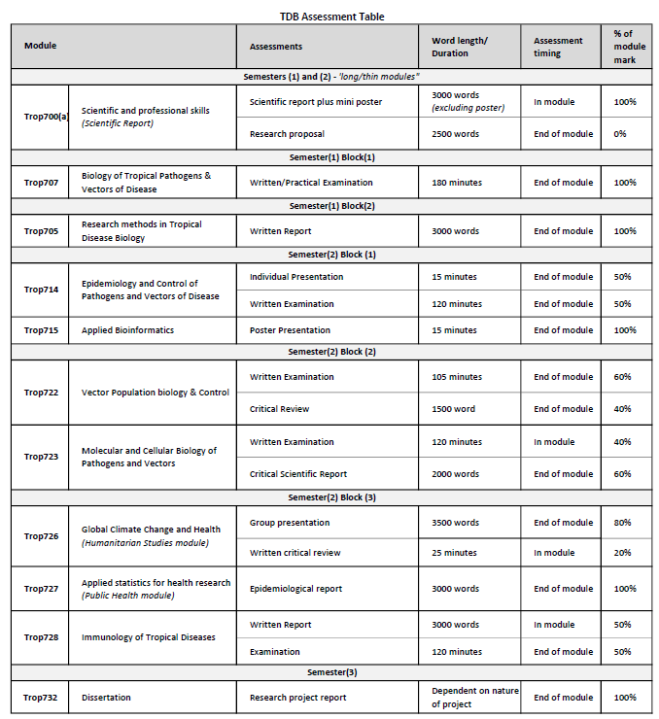
30 | Pass Mark
The pass mark for each module is 50%.
31 | Compensation and Resits
Compensation
Where the overall average mark in all taught modules is 50% or above, a mark of 40-49% in one module of 20 credits will be deemed compensatable. The compensation rule will not apply to stand-alone modules. Marks for modules passed by virtue of the compensation rule will be recorded as a pass mark of 50%.
Re-sits
Students who fail one or more modules at the first attempt will normally be offered one reassessment opportunity for each failed component. Reassessment will normally take place in the defined reassessment period, but where this is not possible, within twelve months of the failed assessment. A failed research project may be submitted on one further occasion only, within one year of the original date of submission. Marks achieved through reassessment will be capped at 50% for the purpose of calculating the overall average mark and determining classification for an award. The actual mark achieved through reassessment will be the mark recorded on the transcript. Students will not be permitted a reassessment opportunity for any module or assignment they have passed, with the aim of improving the mark, except in the case of extenuating circumstances. Further information relating to the re-sitting of examinations, including timing of re-sits, can be found in the LSTM Masters Student Handbook.
32 | Marking Descriptors
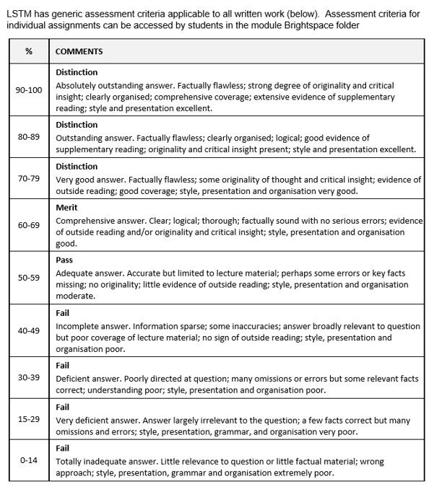

33 | Final Award and Alternative Qualifications
Final Award
Students who attend for a minimum period of 12 months of full-time study, and who achieve a minimum 180 credit points at FHEQ level 7, and successfully complete a dissertation/research project worth 60 credits will be eligible for the award of a Master’s degree. To be awarded the Master's Tropical Disease Biology, the credits achieved must include Trop707 Biology of Tropical Health, Pathogens and Vectors of Disease, Trop705 Research Methods in Tropical Disease Biology and Trop700(a) Scientific and Professional Skills, plus either Trop714 Epidemiology and Control of Tropical Pathogens or Trop715 Applied Bioinformatics.
Students who attend for a minimum period of 30 weeks of full-time study, and who achieve a minimum of 120 credit points at FHEQ level 7, will be eligible for the award of a Postgraduate Diploma. A Postgraduate Diploma shall be comprised either of all taught modules if an entry award or may include the 60-credit research project module if an exit award. To be awarded the Postgraduate Diploma Tropical Disease Biology, as an entry award, candidates must achieve 120 credits from the taught component of the MSc programme to include Trop707 Biology of Tropical Health, Pathogens and Vectors of Disease, Trop705 Research Methods in Tropical Disease Biology and Trop700(a) Scientific and Professional Skills, plus either Trop714 Epidemiology and Control of Tropical Pathogens or Trop715 Applied Bioinformatics. An exit award that includes the dissertation project should also include Trop707 Biology of Tropical Health, Pathogens and Vectors of Disease.
Students who attend for a minimum period of 15 weeks full-time study, and who achieve a minimum of 60 credit points at FHEQ level 7, will be eligible for the award of a Postgraduate Certificate. To be awarded the Postgraduate Certificate Tropical Disease Biology, the credits achieved must include Trop707 Biology of Tropical Health, Pathogens and Vectors of Disease plus at least 20 credits from the modules listed in Section 27c (excluding Trop733 Research Project: Tropical Disease Biology).
A mark of Merit or Distinction will be awarded according to the criteria below.
A Merit or Distinction may be awarded if a student has failed and then passed on re-sit any credit that counts towards the final award during the relevant period of study at LSTM. However, marks are capped at 50% for the purposes of calculating the award.
Marks achieved in modules which are passed under the compensation rule may also be counted towards a Merit or Distinction.
It should be noted that students who register on the MSc TDB, but who exit with a lower award, will be eligible for a Merit or Distinction for the lower award, provided the student meets the criteria outlined below:
For a Master’s degree with Distinction a student must achieve:
- An overall average of at least 70% across all modules, and
- A Distinction grade for the dissertation; or
- a Distinction grade for the average of the taught modules.
For a Postgraduate Diploma with Distinction a student must achieve:
- An overall average mark of at least 70% in 120 credits of modules, which can be made up of the taught modules alone or taught modules and the dissertation (120 Credits).
For a Postgraduate Certificate with Distinction a student must achieve:
- an overall average mark of at least 70% in 60 credits of taught modules
For a Master’s degree with Merit a student must achieve:
- An overall average of at least 60% across all modules, and
- A Merit grade for the dissertation; or
- a Merit grade for the average of the taught modules.
For a Postgraduate Diploma with Merit a student must achieve:
- An overall average mark of at least 60% in 120 credits of modules, which can be made up of the taught modules alone or taught modules and the dissertation (120 Credits).
For a Postgraduate Certificate with Merit a student must achieve:
- an overall average mark of at least 60% in 60 credits of taught modules
Average marks falling up to 2% below any grade boundary are deemed to be borderline cases. In these cases, the award is determined by consideration of the profile of marks across all taught modules. To be awarded the higher grade, at least 50% of the taught credits must be at the higher grade.
Students who take modules on a stand-alone basis will become eligible for an award with Distinction or Merit where they:
- Subsequently register for a programme of study which leads to an award and successfully complete the required credit through the study of appropriate modules as defined in the programme specification or accumulate sufficient credit for an unnamed award in accordance with an approved programme of study.
Where a student has successfully completed modules which exceed the required credit for the award the calculation of the overall average mark and determination of classification will be based on the modules with the higher marks.
Criteria for the award of an alternative qualification
If a student fails to meet the criteria for the award of a Master’s degree or a Postgraduate Diploma, or is unable to complete the programme he or she registered for, they may be eligible for the award of one of the following as an exit qualification:
- Postgraduate Diploma Tropical Disease Biology will be awarded to students who have previously registered for the Master’s degree provided that the student has achieved a minimum of 120 credits. The 120 credits may include dissertation credits to the value of 60 credits. To qualify for the Postgraduate Diploma Tropical Disease Biology the credits achieved must include the following Trop707 Biology of Tropical Health, Pathogens and Vectors of Disease, Trop705 Research Methods in Tropical Disease Biology and Trop700(a) Scientific and Professional Skills, plus either Trop714 Epidemiology and Control of Tropical Pathogens or Trop715 Applied Bioinformatics. An exit award that includes the dissertation project should also include Trop707 Biology of Tropical Health, Pathogens and Vectors of Disease. Students who exit without having achieved the core modules may be eligible for an unnamed Postgraduate Diploma.
- Postgraduate Certificate Tropical Disease Biology will be awarded to students who have previously registered for the Master’s Degree or the Postgraduate Diploma of 60 credits. The credit may not include any dissertation credits. To qualify for the Postgraduate Certificate Tropical Disease Biology the credits achieved must include Trop707 Biology of Tropical Health, Pathogens and Vectors of Disease plus at least 20 credits from the modules listed in Section 27c (excluding Trop733 Research Project: Tropical Disease Biology). Students who exit without having achieved the core modules may be eligible for an unnamed Postgraduate Certificate.

Part F: Quality Assurance
34 | Examination Process
The Masters Board of Examiners consists of the Dean of Education (Chair), Academic Registrar (Secretary), the External Examiners from all LSTM MSc programmes and all members of academic staff who have made a major contribution to the teaching and assessment of the programmes.
The Terms of Reference are as follows:
- To monitor methods of assessment against set learning outcomes and programme requirements
- To ensure standards of assessment are maintained
- To assess students’ performance in accordance with regulations
- To reach overall decisions concerning awards
- To make recommendations to the Board of Studies on the conduct and standards of all assessment procedures
External Examiners are responsible for ensuring that awards made by LSTM are of a comparable standard with those of similar subjects and awards of other Higher Education Institutions in the United Kingdom, as stated in the Code of Practice on External Examining of Taught Programmes which is available at: http://www.lstmed.ac.uk/study/quality-manual
Further information on the assessment policies and procedures can be found in the LSTM Masters Student Handbook, including:
- The penalties for the late submission of assessments
- The rules relating to plagiarism and collusion
- Ill-health and other special factors
Information on the purpose, method and schedule of assessment and the timescales for the submission of assessments can be found in the Programme Handbook (available on the LSTM student intranet) and on the Brightspace programme page.
35 | Student Representation and Feedback
Box 35 Student Representation and Feedback
LSTM is committed to receiving and responding to student feedback in order to develop learning and teaching within the institution and to improve the overall quality of the student experience. Students are encouraged to evaluate individual modules and the programme via an online survey tool. The survey results are reported at Board of Study (BoS) meetings, together with any additional feedback from the student representatives. Regular focus groups will be held and there are opportunities for informal feedback via tutors and module convenors.
Students will be formally represented within the LSTM committee structure:
- The Staff Student Liaison Committee (SSLC) meets 3 times a year and includes an elected representative from each programme, including any programme streams. The minutes of the SSLC are received by the Learning & Teaching Committee (L&TC). The membership of the SSLC, its terms of reference and the manner in which it conducts its business conform to the requirements of the Code of Practice on Student Engagement and Enhancing the Student Experience - http://www.lstmed.ac.uk/study/quality-manual
- Each Master’s programme has a Board of Studies (BoS), which oversees its planning, operation, management and development. Membership of the BOS consists of the Director of Studies for the Programme, the Academic Registrar, elected student representatives, Registry staff supporting the programme, Convenors of Modules and those making a significant contribution to the programme.
Students play an active role in the work of the BoS, with the exception of reserved and confidential business. The minutes of all Boards of Studies are received by the L&TC.
- The Quality Management Committee (QMC) oversees the academic standards and quality assurance and enhancement of all taught programmes, ensuring that LSTM’s quality assurance processes are fully informed by external expectations including the UK Quality Code for Higher Education. Two students from across all programmes serve as full members of the QMC. The QMC reports on academic quality assurance and enhancement issues to the L&T Committee. The Committee meets a minimum of four times per academic year and is responsible for:
- Approving, monitoring and reviewing programmes and modules
- Approving recommendations for the appointment of external examiners for LSTM programmes.
- Monitoring the progress of actions raised by External Examiners
- Developing, monitoring and reviewing the peer observation system

Part G: Diversity and Equality of Opportunity and Widening Participation
36 | Diversity and Equality Statement
The programme’s design, structure and content are consistent and compliant with the Diversity and Equality of Opportunity Policy. LSTM provides a multicultural, multidisciplinary learning environment in which all students benefit from the opportunity to share diverse experiences and outlooks, supported by staff who are themselves from a variety of national and cultural backgrounds and spend significant periods of time working overseas. LSTM recognises that some students need extra help and guidance in adjusting to a new country, culture or learning environment. Accordingly, we provide a comprehensive range of relevant non-academic student support services. The Personal Tutor System aims to provide students with advice and support in matters related to academic work and to enable the development of independent study habits suitable for higher education. Reasonable adjustments are made to assessment for disabled students in line with the Code of Practice on Student Support and Welfare.

Part H: Status of Professional, Statutory or Regulatory Body Accreditation
37 | Accreditation Status
Not applicable

Annex: Modifications
Annex of Modifications made to the Programme - Related List of Modification
Description of Modification (Please include details of any student consultation undertaken or confirm that students’ consent was obtained where this was required) | Major/Minor Modifications | Date Approved by QMC | Date Approved by Mgt Cttee | Cohort Affected

