1 | Title of Programme | Tropical Paediatrics
2 | Programme Code | MSc/TP
3 | Entry Award (s):
3a | Entry Award 1 | MSc – 180 Credits:7
3b | Entry Award 2 | PGDip – 120 Credits:7
3c | Entry Award 3 | PGCert – 60 Credits:7
4 | Exit Award (s):
4a | Exit Award 1 | MSc – 180 Credits:7
4b | Exit Award 2 | PGDip – 120 Credits:7
4c | Exit Award 3 | PGCert – 60 Credits:7

5a | Start Date | September 2023 |  | 5b | End Date | September 2024
6 | Frequency of Intake | Annually in September
7 | Mode of Study | FT
8a | Applicable Framework | LSTM LT REG 01
8b | Exemption Required
8c | Exemption Approved
8d | Details of Exemption
9 | Programme Director | Pui-Ying Iroh Tam
10 | Board of Studies | Clinical Masters Board of Studies
11 | Board of Examiners | MSc Board of Examiners
12 | External Examiner(s) | Dr. Grant Mackenzie
13 | Professional or  Other Body | None
14 | Reference Points | Priorities of relevant national and international organisations in global health (Department for International Development, UK; United States Agency for International Development; World Health Organisation); QAA Master’s Degree Characteristics (2020); The Frameworks for Higher Education Qualifications of UK Degree-Awarding Bodies (2014)
15a | Home/EU Fee |  |  | 15b | Overseas Fee
16 | Additional Costs to the Student | The programme fee covers the cost of a desk-based project based in LSTM. Depending on your previous experience you may be permitted to undertake a lab-based project which will incur an additional fee, called a bench fee which will be approximately £1,500. You may also need to cover the costs of antibody testing and/or vaccinations needed for laboratory projects. Students are not required to pay this additional fee at registration but must have the necessary funds available when they start the programme. LSTM can also help students to arrange a field-based project overseas (typically 4 weeks) and students are encouraged to take this opportunity if your funds allow. Overseas projects will incur costs such as flights accommodation, hiring translators, travel in-country, visas, vaccinations, possibly fees for ethics applications so costs, depending on duration, nature of fieldwork and complexity of project can range from approximately £3,000-£5,000). The School will provide comprehensive insurance for off-site work and cover the cost of this.  While LSTM provides access to the main scientific software packages you will need for your dissertation, occasionally some students use specialist software for their dissertations beyond what LSTM provide and there could be a subscription fee, although often there is a period these can be used for free as a trial. There may additionally be course-relevant and social trips, which are optional for students to attend, and which may have costs attached.

Part B: Programme Aims and Outcomes
17 | Overview of the Programme
This programme develops professional skills including leadership and governance skills along with critical appraisal of evidence as applicable to clinical practice applicable to paediatric healthcare. Research skills as applicable to a wide range of paediatric problems in clinical and epidemiological settings in low- and middle-income settings will be developed including the ethical considerations both in clinical and research practice. Emphasis is given to the scientific and empiric evidence for diagnosis, management and control of the most prevalent diseases in low- and middle-income settings, with particular reference to high burden diseases such as tuberculosis, HIV and malaria, from a public health and clinical perspective. It aims to provide students with knowledge, skills and understanding needed to enable them to contribute to strengthening health systems in support of child health, facilitating the implementation and scale up of good clinical practice, and raising awareness amongst public, fellow professionals and politicians of the need for more effective use of knowledge and tools to impact on various health indicators. Where relevant, various vulnerable groups in society will be discussed in the context of specific medical problems in low- and middle-income settings. Teaching methods will include interactive lectures, case based learning and small group work as well as simulation scenarios.
Following the taught programme, participants will complete a project/dissertation, choosing from a range of options according to the individual interests including a period of applied research, a systematic review, a quality improvement project or a clinical placement, either overseas or in Liverpool. Projects should be discussed early in the course and indeed pre-course for students with specific ideas in mind, to facilitate the appropriate pathway though the programme.
This clinical MSc will have an emphasis on the infectious diseases’ aspects in low- and middle-income settings along with relevant non-infectious clinical problems in the paediatric setting. The course will commence with core teaching on the Evidence application for clinical practice, looking at study design and critical appraisal to then apply that knowledge in practice, the other 2 modules in the 1st semester will be Essentials of Tropical Medicine module and a Leadership and education principles in clinical practice module which will be valuable, and a novel module, designed to equip health care professionals to lead the wider health care team in various areas of clinical practice and how to apply education principles and training to day-to-day clinical work including how to design training programmes and ensure clinical evidence is applied in practice. These generic modules applicable to both adult and paediatric care, will have examples and scenarios in both settings for students on both courses.
18 | Aims of the Programme
No. | Specific Aim |  | Entry Award
1 | Develop students’ knowledge and comprehension of patient safety and quality improvement in health care in the context of child health, to enable students to develop and run their own quality improvement projects to improve the health of people in low- and middle-income settings. |  | All Awards
2 | Will allow students to critically evaluate evidence in the preventive and curative management strategies that promote health and well-being in low- and middle-income countries. |  | All Awards
3 | Facilitate high quality learning that is informed by critical analysis of current research in the area of tropical paediatrics. |  | All Awards
4 | Provide healthcare workers with professional skills including leadership and skills relevant to applying research-based evidence-based medicine in tropical paediatrics in low-and middle-income countries. |  | All Awards
5 | Enable students to comprehend and conduct health-related research. With an option of conducting a piece of health-related research as part of the dissertation |  | MSc Only
6 | Produce graduates who are experienced, committed, informed, pro-active and effective professionals, capable of taking substantial and leading healthcare professional roles. |  | All Awards

19 Skills and Other Attributes
No. |  |  | Skill/Attribute |  | Module(s) | Mode of Assessing
1 |  |  | To communicate ideas, knowledge, and strategies confidently and effectively, to a variety of audiences using a variety of media and technologies. |  | All modules | Written assessments, examinations (MCQ & written),dissertation and presentations (oral, poster)
2 |  |  | To work effectively both independently and in collaboration with others in small and large groups |  | All modules | Written assessments, examinations (MCQ & written),dissertation and presentations (oral, poster)
3 |  |  | To take responsibility for self-managed learning |  | All modules | Written assessments, examinations (MCQ & written),dissertation and presentations (oral, poster)
4 |  |  | To apply numerical and IT skills with confidence and accuracy. To integrate technology into learning |  | Trop709 | Literature search, critical review
5 |  |  | To apply skills, including leadership skills, in effective project and time management to set goals, prioritise activities and meet deadlines |  | All modules | Written assessments, examinations (MCQ & written),dissertation and presentations (oral, poster)
20 |  | Subject Based Learning Outcomes
A |  | Knowledge and Understanding. Upon successful completion of the programme, a student should have developed and be able to demonstrate:
No. |  | Learning Outcome |  | Module(s) |  | Mode of Assessing | Entry Award
A1 |  | Critique current issues and priorities in the field of tropical medicine with specific focus on paediatric aspects of health care. |  | All modules |  | Written assessments, examinations (MCQ & written), project proposal, project dissertation/report, presentations (oral, poster) | All Awards
A2 |  | Apply appropriate research and quality improvement methods to address pertinent questions or quality improvement concerns, with particular reference to patient safety and delivery of high-quality care, particularly in child health scenarios |  | 709, 710, 716, 734 |  | Presentation, critical review; portfolio of evidence (critical appraisal, critical review, synthesis essay), QI proposal. project proposal, project dissertation/report. | MSc & PGDip Only
A3 |  | Appraise how health systems and services respond to health issues pertinent to child health |  | 730, 710 |  | Portfolio of evidence (critical appraisal, critical review, synthesis essay), written control programme report. | MSc & PGDip Only
A4 |  | Critique health research and apply statistical knowledge to the understanding of research studies. |  | 709 734 |  | Written reports, critical appraisal of research ,project proposal, project dissertation/report. | MSc & PGDip Only
A5 |  | Apply appropriate skills related to the diagnosis, management and control of tropical parasitic, bacterial, viral and fungal infections in children and where relevant in adults for example in transitional age group. as well as the interplay with non-communicable diseases in a variety of regional and resource settings. |  | 711, 724, 725, 729 |  | Written exams, poster presentation, written assessments | MSc & PGDip Only
B |  | Cognitive Skills. Upon successful completion of the programme, a student should be able to:
No. |  | Learning Outcome |  | Module(s) |  | Mode of Assessing | Entry Award
B1 |  | Critically analyse, synthesise and evaluate information from a variety of sources |  | 709, 734 |  | Written assessments, project proposal, project dissertation/report. | MSc & PGDip Only
B2 |  | Apply subject knowledge and understanding in a variety of contexts to analyse and reach evidence-based conclusions on complex situations, problems and opportunities |  | 711, 724, 725, 729, 734 |  | Poster presentations written exams, project proposal, project dissertation/report. | MSc & PGDip Only
B3 |  | Apply the principles and values of ethical practice with regard to the design and conduct research or quality improvement studies, in the collection, analysis, interpretation and presentation of data, and publication |  | 734 |  | project proposal, project dissertation/report. | MSc Only
B4 |  | Demonstrate creativity, innovation and originality in the application of knowledge |  | All modules |  | Written assessments, examinations (MCQ & written), project proposal, project dissertation/report. presentations (oral, poster) | All Awards
B5 |  | Learn independently through continuous professional development |  | 710 |  | Portfolio ((critical appraisal, critical review, synthesis essay) | MSc & PGDip Only
C |  | Practical/Professional Skills. Upon successful completion of the programme, a student should be able to:
No. |  | Learning Outcome |  | Module(s) |  | Mode of Assessing | Entry Award
C1 |  | Manage time and resources effectively |  | All modules |  | Written assessments, examinations (MCQ & written), project proposal, project dissertation/report, presentations (oral, poster) | All Awards
C2 |  | Take a leadership role in managing patients, teams, clinical services and in managing projects. |  | All modules |  | Written assessments, examinations (MCQ & written), project proposal, project dissertation/report. presentations (oral, poster) | All Awards
C3 |  | Communicate effectively with colleagues, patients and the public and act as an advocate to improve health for all and especially for disadvantaged groups |  | All modules |  | Written assessments, examinations (MCQ & written), project proposal, project dissertation/report, presentations (oral, poster) | All Awards
C4 |  | Undertake a project (e.g. research, QI etc.) in a responsible, safe and ethical manner and accurately record the data collected |  | 710, 716, 734 |  | Portfolio of evidence ((critical appraisal, critical review, synthesis essay) presentation, QI project proposal, project proposal, project dissertation/report. | MSc & PGDip Only
21 | Career Opportunities
This MSc provides a wide range of skills for health care workers working in child health in low- and middle- income settings. The skills learnt can empower those who wish to plan leadership and or academic careers in resource-poor settings. It is an excellent qualification for those who wish to work in any area of child health including research, as well as with international organisations specialising in health assistance-related activities. Many students have had research projects published in peer reviewed journals, enhancing their standing in the academic arena. This new course will provide the methodology for quality improvement projects and aims to have similar successful publications. Future leaders in the area of tropical paediatrics are crucial, particularly in context of emerging infections: leading in clinical management, research and infection control, and students from this course will be equipped to develop lifelong learning to be the future leaders in global child health.

Part C: Entrance Requirements

22 | Academic Requirements | Open to healthcare graduates with experience of professional work in clinical settings (preferably in LMICs) and at least one year’s experience of professional work in clinical paediatrics after qualification. In exceptional circumstances, medical students without this experience, but with an interest in clinical paediatrics, may also be considered.
23 | English Language Requirements | The programme is taught in English. Applicants whose first language is not English must normally provide evidence of an IELTS (International English Language Testing System) score of at least 6.5 with a minimum of 5.5 in all learning components, or a TOEFL (Test of English as a Foreign Language) score of at least 88 for the Internet-based Test (iBT), with minimum scores of 21 for Listening and Writing, 22 for Reading and 23 for Speaking. Tests should be within their validity period of 2 years. Other English Language Tests and country specific English Language qualifications are also accepted – a full list with details of levels required can be found on the LSTM website (http://www.lstmed.ac.uk/study/how-to-apply/english-language-requirements). Applicants who have recently completed a degree level qualification taught in a majority English speaking country (as defined by UK Visas and Immigration (UKVI)) may also be accepted at the discretion of the Director of Studies.
24 | Recognition of Prior Learning | All programmes of study will permit entry with credit attributed to previous certificated study up to a total of one third of the credits required to be awarded a MSc Degree, Postgraduate Diploma, Postgraduate Certificate or Postgraduate Award.
25 | Work Experience | Non-graduates with considerable satisfactory work experience and evidence of appropriate in-service training will also be considered. Experience of working in a developing country is desirable.
26 | Other Requirements | None

Part D: Programme Structure
27a | Overview
The programme is offered within a dynamic research-led environment and its content is informed by the cutting-edge research activities of the academic staff. It is designed to enable the professional development of the student, to be relevant to students from both the UK and overseas and to promote approaches to study that will enable graduates to continue their learning into the future.
The programme comprises an introductory induction week, taught modules totalling 120 credits and a 60 credit dissertation. A 10 credit module (5 ECTS credits) represents 100 hours of student learning activity including assessment and self-directed study. Many students carry out a fieldwork-based dissertation project overseas but students can opt to conduct a laboratory or literature-based project that does not involve travelling abroad. All types of project have the key aims of developing the students’ skills in formulating a research question, designing and implementing a research project and critically interpreting and presenting the findings.
The modules available to students following the programme are shown in Section 27b. Required modules are necessary to achieve the programme learning outcomes and must be taken by all students following the programme. Exceptionally, students choosing a laboratory-based project may, with the approval of the Director of Studies and subject to any restrictions on class size, choose to take TROP936 in place of the related module TROP934. The two modules share teaching on epidemiology, statistics and proposal development but TROP936 includes laboratory classes in place of the TROP934 sessions on qualitative research skills. Both modules allow the student to achieve the learning outcomes of the programme.
The optional modules listed have been identified as most suitable for contributing to the attainment of the programme learning outcomes. However, depending on their background or interests, students may opt to replace a recommended optional module with one offered as part of another LSTM MSc programme (Section 27c), subject to the agreement of the Director of Studies and any restrictions on class size.

27b | Timetable
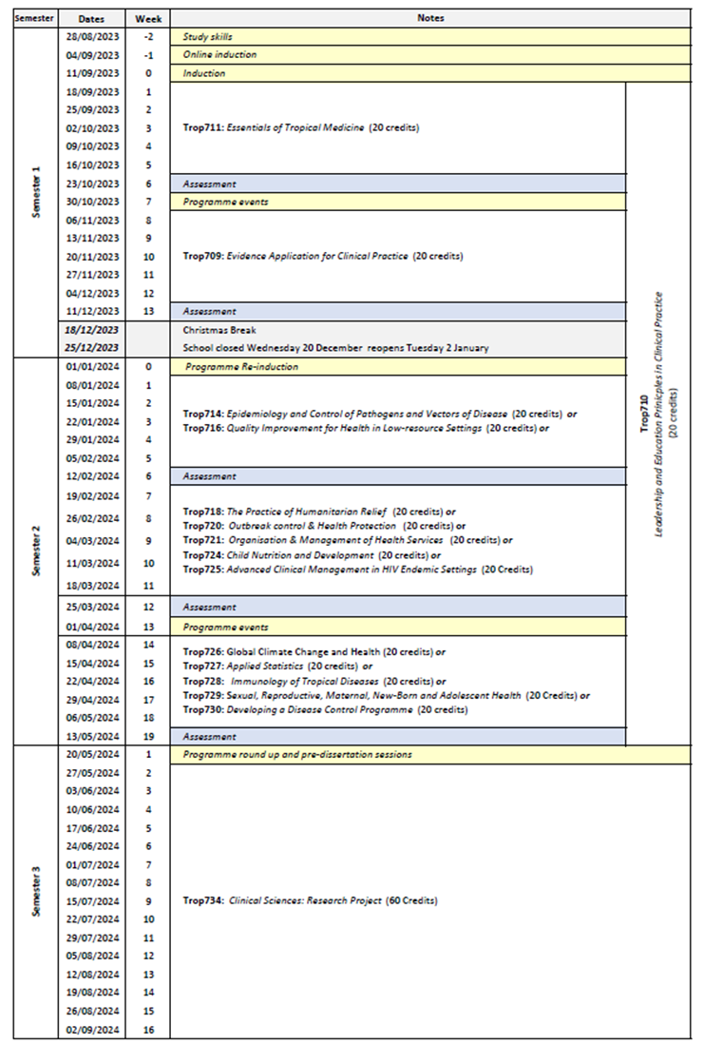
Semester 1: Core modules (all modules 20 credits)
Trop709: Evidence Application for Clinical Practice
Trop710: Leadership and Education Principles for a Clinical Service
Trop711: Essentials of Tropical Medicine
Semester 2 – all modules are 20 credits,
Block 1
Trop716: Quality Improvement for Health in Low Resource Settings
Block 2:
Trop724 Child Nutrition and Development*
Trop725 Advanced Clinical Management in HIV Endemic Settings
Block 3:
Trop727 Applied Statistics for Health Research (on MTDB and MPHI programmes)
Trop729 Sexual, Reproductive, Maternal, New-Born and Adolescent Health*
Trop730 Developing a Disease Control Programme
*Either Trop724: Child Nutrition and Development or the Trop729: Sexual Reproductive Maternal New-born and Adolescent Health is required for Masters in Tropical Paediatrics
Note Additional optional modules form other Masters programmes outlined in section 27c below.
Semester 3
Long project taken either in Liverpool or overseas on an area of child health.
Project may be:
- research (developing project or analysing secondary data)
- systematic review
- quality improvement project
- clinical placement with a critical reflective thesis on a topic identified during the clinical placement.
Depending on the project to be taken in the 3rd semester, students will be directed as to which modules will be best for those projects. For example, a student wishing to perform a quality improvement project will be encouraged to take the Quality improvement for health in low resource settings.

27c | Options
Modules from other master programmes that may be options (all are 20 credits)
Semester 2
Block 1
Trop714: Epidemiology and Control of Tropical Pathogens
Block 2
Trop718: The Practice of Humanitarian Relief
Trop720: Outbreak Control and Health Protection
Trop721: Organisation and Management of Health Services
Block 3
Trop728: Immunology of Tropical Diseases

Part E: Learning, Teaching and Assessment Strategies
28 | Learning, Teaching & Assessment Strategy
The L&T strategy is designed to help all students to express their full potential through a combination of formal teaching and directed student-centred learning. Lectures highlight key points and provide participants with a core knowledge base. Students are expected to enhance this core knowledge and become reflective independent learners through guided enquiry-based self- study and use of on-line learning packages. Self-study is supported by informal staff contact, scheduled help sessions and on-line discussion. To develop cognitive and intellectual skills, the programme involves discussion of key issues, analysis and interpretation of resource material and practice in applying concepts and solving problems. Group work develops students’ abilities to work co-operatively, promotes creativity, provides opportunities to reflect critically and enables participants to take more responsibility for their own learning, as well as learn from each other. Practical skills are developed through opportunities to practise activities in the laboratory and in the field. Students can also take advantage of lectures given by the many distinguished researchers and policy-makers who regularly visit LSTM. The L&T methods adopted reflect the diversity of the LSTM student population and an ethical and culturally sensitive approach is emphasised throughout.
The assessment strategy is designed to encourage the student to develop and improve on a range of skills, including synthesising and evaluating information, academic writing, numerical and IT skills, team-working, presentation skills, and time management. Both formative and summative assessment approaches are used. General assessment procedures, assessment criteria and regulations with respect to late submission are communicated to the students in the LSTM Masters Student Handbook. Students are directed to the relevant module area in the Virtual Learning Environment (VLE) Brightspace for information relating to specific assignments.

29 | Assessment Schedule
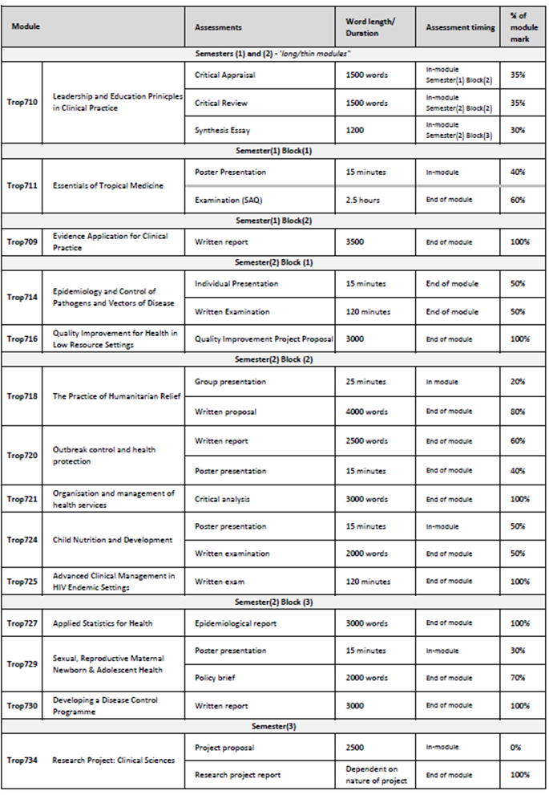
30 | Pass Mark
The pass mark for each module is 50%.
31 | Compensation and Resits
Compensation
Where the overall average mark in all taught modules is 50% or above, a mark of 40-49% in one module of 20 credits will be deemed compensatable. Marks for modules passed by virtue of the compensation rule will be recorded as a pass mark of 50%.
Re-sits
Students who fail one or more modules at the first attempt will normally be offered one reassessment opportunity for each failed component. Reassessment will normally take place in the defined reassessment period, but where this is not possible, within twelve months of the failed assessment. A failed research project may be submitted on one further occasion only, within one year of the original date of submission. Marks achieved through reassessment will be capped at 50% for the purpose of calculating the overall average mark and determining classification for an award. The actual mark achieved through reassessment will be the mark recorded on the transcript. Students will not be permitted a reassessment opportunity for any module or assignment they have passed, with the aim of improving the mark, except in the case of extenuating circumstances Further information relating to the re-sitting of examinations, including timing of re-sits, can be found in the LSTM Masters Student Handbook.
32 | Marking Descriptors
LSTM has generic assessment criteria applicable to all written work (below). Assessment criteria for individual assignments can be accessed by students in the module Brightspace folder.
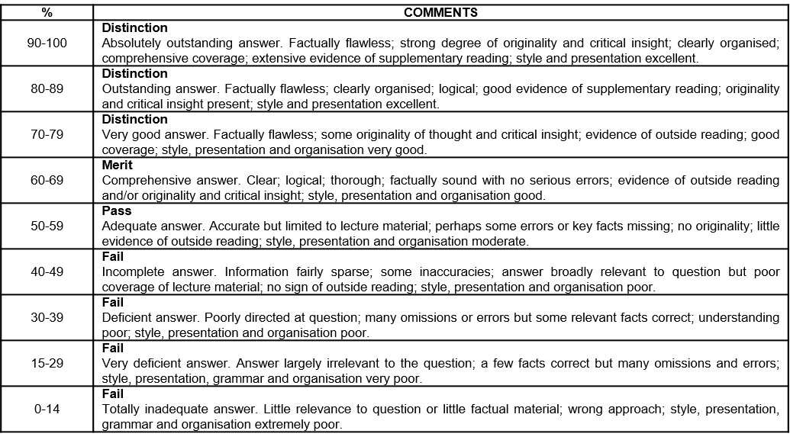
33 | Final Award and Alternative Qualifications
Final Award
Students who attend for a minimum period of 12 months of full-time study, and who achieve a minimum 180 credit points at FHEQ level 7, and successfully complete a dissertation/research project worth 60 credits will be eligible for the award of a Master’s degree. To achieve the MSc Tropical Paediatrics, credits achieved must includeTrop711 Essentials in Tropical Medicine and either Trop724 Child Nutrition and Development or Trop729 Sexual Reproductive Maternal Newborn and Adolescent Health.
Students who attend for a minimum period of 30 weeks of full-time study, and who achieve a minimum of 120 credit points at FHEQ level 7, will be eligible for the award of a Postgraduate Diploma. A Postgraduate Diploma shall be comprised either of all taught modules if an entry award or may include the 60-credit research project module if an exit award. To be awarded the Postgraduate Diploma Tropical Paediatrics, candidates must achieve 120 credits from the taught component of the MSc programme (i.e. excluding the dissertation/ long project) as detailed in Table 1, including Trop711 Essentials in Tropical Medicine and either Trop724 Child Nutrition and Development or Trop729 Sexual Reproductive Maternal Newborn and Adolescent Health.
Students who attend for a minimum period of 15 weeks full-time study, and who achieve a minimum of 60 credit points at FHEQ level 7, will be eligible for the award of a Postgraduate Certificate. To be awarded the Postgraduate Certificate Tropical Paediatrics Diseases, the credits achieved must include Trop711 Essentials of Tropical Medicine and Trop724 Child Nutrition and Development or Trop729 Sexual Reproductive Maternal Newborn and Adolescent Health. plus 20 credits from the modules listed in Table 1 (excluding Trop734 Clinical Sciences Research Project).
A mark of Merit or Distinction will be awarded according to the criteria below.
A Merit or Distinction may be awarded if a student has failed and then passed on re-sit any credit that counts towards the final award during the relevant period of study at LSTM. However, marks are capped at 50% for the purposes of calculating the award.
Marks achieved in modules which are passed under the compensation rule may also be counted towards a Merit or Distinction.
It should be noted that students who register on the MPH(I), but who exit with a lower award, will be eligible for a Merit or Distinction for the lower award, provided the student meets the criteria outlined below:
For a Master’s degree with Distinction a student must achieve:
- An overall average of at least 70% across all modules, and
- A Distinction grade for the dissertation; or
- a Distinction grade for the average of the taught modules.
For a Postgraduate Diploma with Distinction a student must achieve:
- An overall average mark of at least 70% in 120 credits of modules, which can be made up of the taught modules alone or taught modules and the dissertation (120 Credits).
For a Postgraduate Certificate with Distinction a student must achieve:
- an overall average mark of at least 70% in 60 credits of taught modules
For a Master’s degree with Merit a student must achieve:
- An overall average of at least 60% across all modules, and
- A Merit grade for the dissertation; or
- a Merit grade for the average of the taught modules.
For a Postgraduate Diploma with Merit a student must achieve:
- An overall average mark of at least 60% in 120 credits of modules, which can be made up of the taught modules alone or taught modules and the dissertation (120 Credits).
For a Postgraduate Certificate with Merit a student must achieve:
- an overall average mark of at least 60% in 60 credits of taught modules
Average marks falling up to 2% below any grade boundary are deemed to be borderline cases. In these cases, the award is determined by consideration of the profile of marks across all taught modules. To be awarded the higher grade, at least 50% of the taught credits must be at the higher grade.
Students who take modules on a stand-alone basis will become eligible for an award with Distinction or Merit where they:
  - Subsequently register for a programme of study which leads to an award and successfully complete the required credit through the study of appropriate modules as defined in the programme specification or accumulate sufficient credit for an unnamed award in accordance with an approved programme of study.
Where a student has successfully completed modules which exceed the required credit for the award the calculation of the overall average mark and determination of classification will be based on the modules with the higher marks.
Criteria for the award of an alternative qualification
If a student fails to meet the criteria for the award of a Master’s degree or a Postgraduate Diploma, or is unable to complete the programme he or she registered for, they may be eligible for the award of one of the following as an exit qualification:
Postgraduate Diploma Tropical Paediatrics will be awarded to students who have previously registered for the Master’s degree provided that the student has achieved a minimum of 120 credits. The 120 credits may include dissertation credits to the value of 60 credits. To qualify for the Postgraduate Diploma Tropical Paediatrics the credits achieved must include Trop711 Essentials of Tropical Medicine and either Trop724 Child Nutrition and Development or Trop729 Sexual Reproductive Maternal Newborn and Adolescent Health or Trop734 Research Project: Clinical Sciences. Students who exit without having achieved the core modules may be eligible for an unnamed Postgraduate Diploma.
Postgraduate Certificate Tropical Paediatrics will be awarded to students who have previously registered for the Master’s Degree or the Postgraduate Diploma of 60 credits. The credit may not include any dissertation credits. To qualify for the Postgraduate Certificate Tropical Paediatrics the credits achieved must include Trop711 Essentials of Tropical Medicine and either Trop724 Child Nutrition and Development or Trop729 Sexual Reproductive Maternal Newborn and Adolescent Health. Students who exit without having achieved the core modules may be eligible for an unnamed Postgraduate Certificate.

Part F: Quality Assurance
34 | Examination Process
The Masters Board of Examiners consists of the LSTM Dean of Education (Chair), Academic Registrar (Secretary), the External Examiners from all LSTM MSc programmes and all members of academic staff who have made a major contribution to the teaching and assessment of the programmes.
The Terms of Reference are as follows:
- To monitor methods of assessment against set learning outcomes and programme requirements
- To ensure standards of assessment are maintained
- To assess students’ performance in accordance with regulations
- To reach overall decisions concerning awards
- To make recommendations to the Board of Studies on the conduct and standards of all assessment procedures
External Examiners are responsible for ensuring that awards made by LSTM are of a comparable standard with those of similar subjects and awards of other Higher Education Institutions in the United Kingdom, as stated in the Code of Practice on External Examining of Taught Programmes which is available at: http://www.lstmed.ac.uk/study/quality-manual.
Further information on the assessment policies and procedures can be found in the LSTM Masters Student Handbook, including:
- The penalties for the late submission of assessments
- The rules relating to plagiarism and collusion
- Ill-health and other special factors
Information on the purpose, method and schedule of assessment and the timescales for the submission of assessments can be found in the Programme Handbook (available on the LSTM student intranet) and on the Brightspace programme page.
35 | Student Representation and Feedback
LSTM is committed to receiving and responding to student feedback in order to develop learning and teaching within the institution and to improve the overall quality of the student experience. Students are encouraged to evaluate individual modules and the programme via an online survey tool. The survey results are reported at Board of Study (BoS) meetings, together with any additional feedback from the student representatives. Regular focus groups will be held and there are opportunities for informal feedback via tutors and module convenors.
Students will be formally represented within the LSTM committee structure:
- The Staff Student Liaison Committee (SSLC) meets 3 times a year and includes an elected representative from each programme, including any programme streams. The minutes of the SSLC are received by the Learning & Teaching Committee (L&TC). The membership of the SSLC, its terms of reference and the manner in which it conducts its business conform to the requirements of the Code of Practice on Student Engagement and Enhancing the Student Experience - http://www.lstmed.ac.uk/study/quality-manual
- Each Master’s programme has a Board of Studies (BoS), which oversees its planning, operation, management and development. Membership of the BOS consists of the Director of Studies for the Programme, the Academic Registrar, elected student representatives, Registry staff supporting the programme, Convenors of Modules and those making a significant contribution to the programme.
Students play an active role in the work of the BoS, with the exception of reserved and confidential business. The minutes of all Boards of Studies are received by the L&TC.
- The Quality Management Committee (QMC) oversees the academic standards and quality assurance and enhancement of all taught programmes, ensuring that LSTM’s quality assurance processes are fully informed by external expectations including the UK Quality Code for Higher Education. Two students from across all programmes serve as full members of the QMC. The QMC reports on academic quality assurance and enhancement issues to the L&T Committee. The Committee meets a minimum of four times per academic year and is responsible for:
- Approving, monitoring and reviewing programmes and modules
- Approving recommendations for the appointment of external examiners for LSTM programmes.
- Monitoring the progress of actions raised by External Examiners
Developing, monitoring and reviewing the peer observation system

Part G: Diversity and Equality of Opportunity and Widening Participation
36 | Diversity and Equality Statement
The programme’s design, structure and content are consistent and compliant with LSTM's Diversity and Equality of Opportunity Policy. LSTM provides a multicultural, multidisciplinary learning environment in which all students benefit from the opportunity to share diverse experiences and outlooks, supported by staff who are themselves from a variety of national and cultural backgrounds and spend significant periods of time working overseas. LSTM recognises that some students need extra help and guidance in adjusting to a new country, culture or learning environment. Accordingly, we provide a comprehensive range of relevant non-academic student support services. The Personal Tutor System aims to provide students with advice and support in matters related to academic work and to enable the development of independent study habits suitable for higher education. Reasonable adjustments are made to assessment for disabled students in line with the Code of Practice on Student Support and Welfare.

Part H: Status of Professional, Statutory or Regulatory Body Accreditation
37 | Accreditation Status
Not applicable

Annex: Modifications
Annex of Modifications made to the Programme - Related List of Modification
Description of Modification (Please include details of any student consultation undertaken or confirm that students’ consent was obtained where this was required) | Major/Minor Modifications | Date Approved by QMC | Date Approved by Mgt Cttee | Cohort Affected

